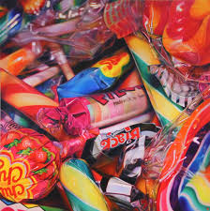
2. Draw an accurately measured grid, with some support, understanding how it can support them with their drawing.
Use the grid to translate a photograph to a drawn image that is mostly correctly proportioned.

1. Know about great artists, craft makers and designers, and understand the historical and cultural development of their art forms:
Learn about photorealism and gain inspiration from looking at art by artists: Chuck Close; Sarah Graham; Oscar Ukonu; Michael Gaskell.

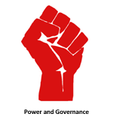
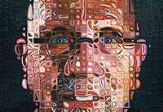
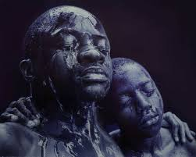
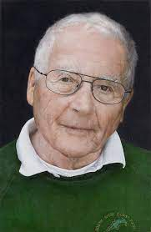
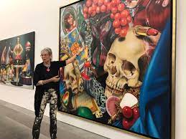
What does it mean to be powerful?
Focus: Power and Governance
Key concepts: How ideas develop through an artistic process.
Purpose: Explore and create photorealistic portraits.

5. Evaluate and analyse creative works using the language of art, craft and design.
4. Create a final painting or drawing with tonal differences that create a photo-realistic effect.
3. Demonstrate observation and proportion to create art in a photorealistic style

