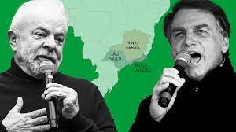
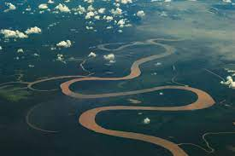
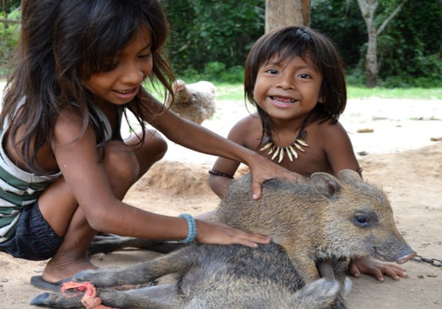
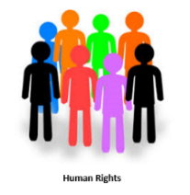

4. Geography / History
Is deforestation a problem for human rights?
I can identify causes and effects of actions and events and suggest reasons for them backed up by evidence. I can compare the history of environmentally responsible living and global inequalities in ecological footprints around the world.
3: History, Geography
Introduction to the Awa tribe. Compare and contrast with their own lives and culture.
I know that people both now and, in the past, including myself, have a point of view and that this can affect interpretation of the past. Identify and describe how the physical features affect the human activity within a location.

1 Geography.
First, we will learn about Deforestation and the impact now on the Rainforest and the world.
Describe and understand key aspects of physical geography, including climate zones, biomes and vegetation belts and human geography, including land use.

Can the Amazon Rainforest be sustainable? Focus: Human Rights
Purpose
A debate on the positives and negatives of deforestation for human rights.
Key concepts
- A deep understanding of the causes and effects of climate change and its historical basis.
- Describe how locations around the world are changing and explain some of the reasons for change.
- Collect and analyse statistics and other information in order to draw clear conclusions about locations.

2: History, Geography

We will then learn about the history of deforestation.

I understand the basic causes and effects of climate change and its historical basis.

