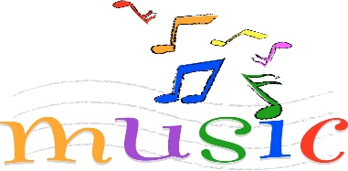

Week 1 –
Introduction to Samba
To recognise and identify the main features of samba music.
Week 2 –
Pulse and rhythm
To understand and play syncopated rhythms.

Y4 – Music
Summer 1
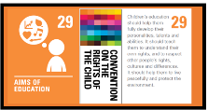
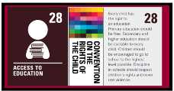



Week 5 –
Samba performance
To perform rhythmic breaks within the samba piece.

Week 6 –
Consolidation
Week 4 –
Composing a break
To compose a basic rhythmic break,
Week 3 –
Samba rhythms
To play syncopated rhythms as part of a group.
Samba and carnival sounds and instruments (Theme: South America)
Intended outcome for the unit;
- Explain what samba music is and that it is mainly percussion instruments used in celebrations such as Carnival in Brazil.
- Clap on the off beat (the and of each beat) and be able to play a syncopated rhythm.
- Play their rhythm in time with the rest of their group (even if they are not always successfully playing in time with the rest of the class).
- Play their break in time with the rest of their group and play in the correct place in the piece.
- Play in time and with confidence; accurately playing their break.

