Welcome to Spring 2 Year 3!

History and Geography

This half term our global theme with be Peace and Conflict. We will be learning about the Second World War and its impact on Sheffield. We will also be giving the children role play experiences to help them to understand what life was like for child evacuees. As part of Geography, we will look at how the use of land changed during WWII and the geographical reasons why bombs were dropped in and around Darnall.

Maths

Maths will see us continue our journey with fractions, adding up and subtracting fractions and beginning to apply reasoning to our understanding of fractions. We will continue to learn and apply knowledge of times tables (2,5,3,4,8,10) and cover mass and capacity – moving between units of measurement eg. converting from kg to gs etc. And applying reasoning to further our understanding of weight and measure.

English
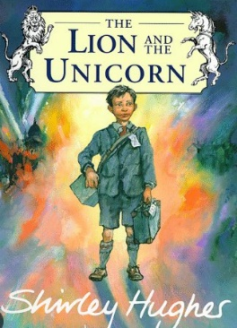
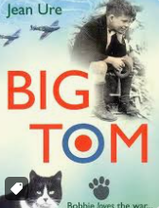
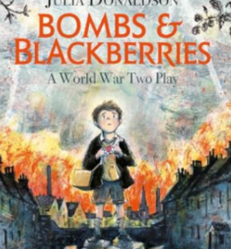

In English, we will immerse ourselves in WWII, as we will be producing a piece of persuasive writing, using powerful descriptive vocabulary. The children will focus on speaking to support their writing and on how to formulate a letter to persuade someone – a useful skill! Some children will continue to work on narrated sentences to support their writing; while others will be working with increased independence.

Book Study

In Book Study we will build on skills in fluency, oracy and comprehension with children given plenty of opportunities to read out loud and make inferences about characters, themes and ideas in the texts we read. These will include, The Lion and the Unicorn by Shirley Hughes, Bombs and Blackberries by Julia Donaldson and Big Tom by Jean Ure.

Science

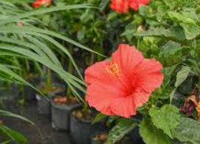
In Science we will be learning about plants; how the parts function; how water is transported in a plant; investigating how seeds disperse and what makes a seed germinate fastest as well as the impact of different fertilisers.

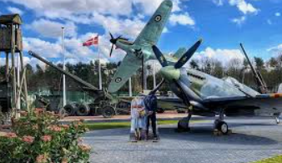
Visits
We will soon be sending out information on our Year 3 visit to Eden Camp Modern History Museum (the visit will take place on Tuesday 21st April 2026.

A fundraiser will happen this half-term to help pay for the cost of the visit. Please support us!

PE

Our PE days are Wednesday and Friday. Please ensure that your child is wearing full PE kit. No earrings please on these days. Gymnastics is barefoot, so no tights on PE days please.

Home learning

- Spellings are given out on Friday and tests happen on Friday mornings.
- IXL and Times tables Rockstars. Please ask if log ins are lost.
- Children must learn their 3, 2,5, 10, 8 and 4 times tables.The tables need to be learned so children are fast and can complete them in any order.
- Children not completing homework at home will need to do this at school during lunchtime homework club.

