
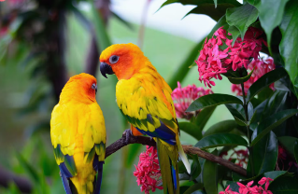
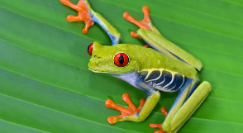
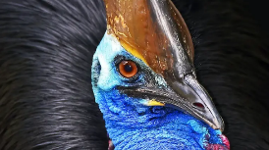

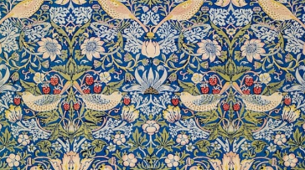
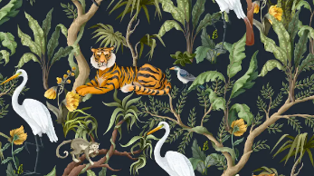


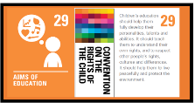
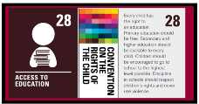
Y4 – Summer 1
Craft and Design: Fabric of Nature
Week 1: Inspired by the rainforest.
To understand starting points in a design process.

Week 5: Fabric design.
To understand how art is made for different purposes.

Week 4: Repeating patters.
To learn how to create a repeating pattern.

Unit Outcomes:
Pupils who are secure will be able to:
- Describe objects, images and sounds with relevant subject vocabulary.
- Create drawings that replicate a selected image.
- Select imagery and colours to create a mood board with a defined theme and colour palette.
- Complete four drawings, created with confident use of materials and tools to add colour.
- Understand the work of William Morris, using subject vocabulary to describe his work and style.
- Create a pattern using their drawing, taking inspiration from mood boards and initial research to develop it.
- Identify and explain where a pattern repeats.
- Follow instructions to create a repeating pattern, adding extra detail.
- Understand different methods of creating printed fabric in creative industries.
- Use sketchbooks to evaluate patterns.
- Produce ideas to illustrate products using their designs.

Week 3: Creating patterns.
To explore using a textile technique to develop patterns.

Week 2: One picture, four views.
To explore techniques to develop imagery.

