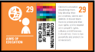
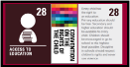
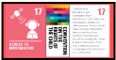


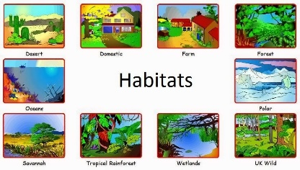
1) Grouping Things
Recognise that living things can be grouped in a variety of ways and to identify changes, patterns, and similarities and differences.

7) End of unit assessment
6) Environmental Changes
Recognise that environments can change and that this can sometimes pose dangers to living things.
5). Local Habitat Study
Recognise that environments can change and that this can sometimes pose dangers to living things and to gather, record and present observations in a variety of ways to help answer questions.
3) Invertebrate Hunt
Explore and use classification keys to help group, identify and name a variety of living things in their local and wider environment and to make systematic and careful observations.
2) Classifying Vertebrates
Recognise that living things can be grouped in a variety of ways and to identify, group and classify things, using simple keys when appropriate.
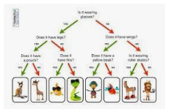
Y4 – Autumn 1
Living things and their habitats
Why do different animals live in different habitats and what are the differences between? these habitats?
Skills we will be using:
- Ask relevant questions.
- Gather, record classify and present data in a variety of ways to help in answering questions.
- Identify differences, similarities or changes related to simple, scientific ideas and processes.
- Recognise that living things can be grouped in a variety of ways.
- Explore and use classification keys.
- Recognise that environments can change and that this can sometimes pose dangers to specific habitats.
- Identify how animals and plants are suited to and adapt to their environment in different ways.

4) Classification Keys
Explore and use classification keys to help group, identify and name a variety of living things in their local and wider environment.

