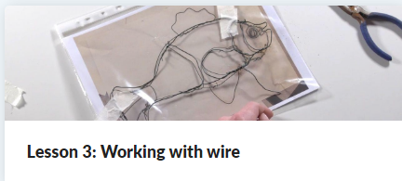
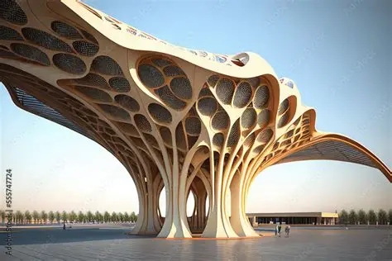
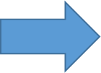
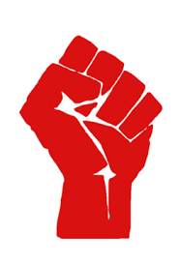
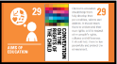
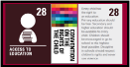
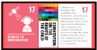
4) Shadow Sculpture
To consider the effect of how sculpture is displayed.

3) Working with wire
To explore how shapes can be formed and joined in wire.

2) Soap sculptures
To use more complex techniques to shape materials.

1). From 2D to 3D
To develop ideas for 3D work through drawing and visualisation in 2D.

Sculpture and 3D: Mega Materials
How can structures represent power?
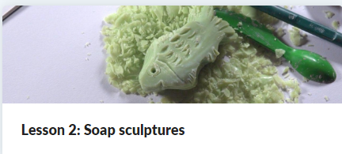
Skills we will be using:
- Generate ideas from a range of stimuli, using research and evaluation of techniques to develop their ideas and plan more purposefully for an outcome.
- Use sketchbooks for a wider range of purposes, for example, recording things using drawing and annotations, planning and taking the next steps in a making process.
- Demonstrate greater skill and control when drawing and painting to depict forms, such as showing an awareness of proportion and being able to create 3D effects.
- Use more complex techniques to shape and join materials, such as carving and modelling wire.
- Use subject vocabulary confidently to describe and compare creative works.
- Understand how artists use art to convey messages through the choices they make.
- Use more complex vocabulary when discussing their own and others’ art.
- Discuss art, considering how it can affect the lives of the viewers or users of the piece.

5). Recycle and recreate
To choose and join a variety of materials to make sculpture.
Y4 – Autumn 1
Art

