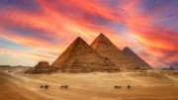
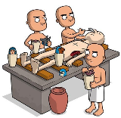
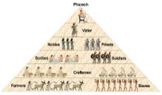
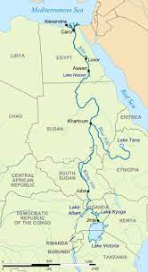
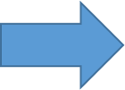
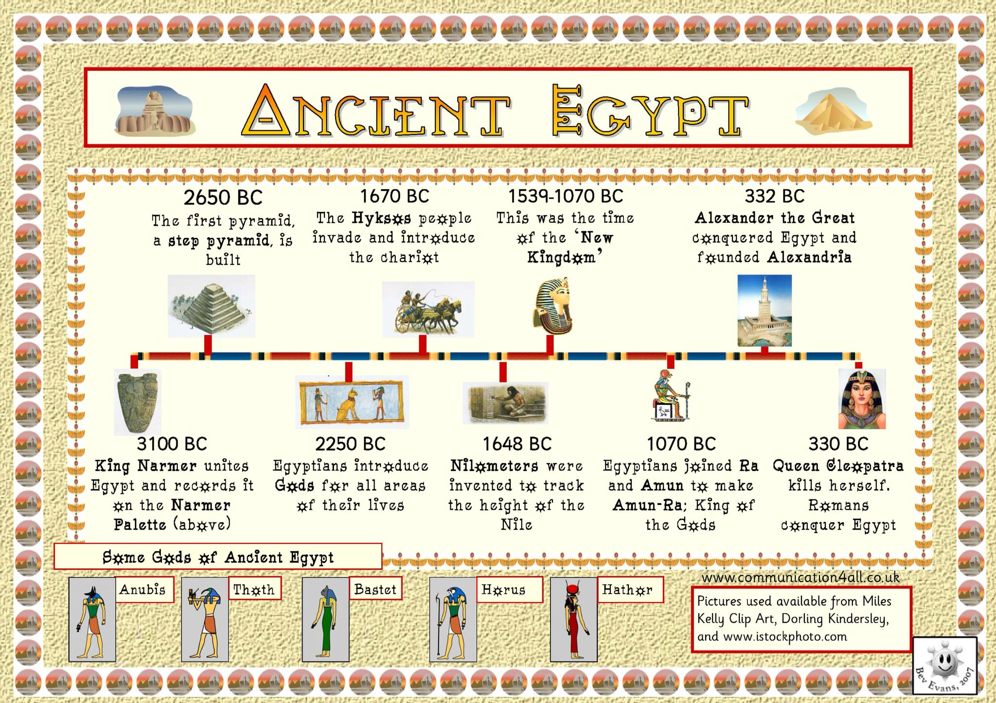
1. We will recap our transition week learning on Egypt and look at important Egyptian events on a timeline.
(History)

Power + Governance
Key Concept: Investigate and interpret the past
Purpose
To understand how Ancient Egyptians lived and what the similarities
and differences are between life then and now.
History: Use evidence to ask questions and find answers to questions about the past.
Suggest suitable sources of evidence for historical enquiries.
Use more than one source of evidence for historical enquiry in order to gain a more accurate understanding of history.
Place events, artefacts and historical figures on a time line using dates.
Understand the concept of change over time, representing this, along with evidence, on a time line. Use dates and terms to describe events.
Use appropriate historical vocabulary to communicate, including dates, time, period, era change and chronology.
Geography: Ask and answer geographical questions about the physical characteristics of a location. Explain own views about locations, giving reasons.
Use maps, atlases and digital/computer mapping to locate countries and describe features.

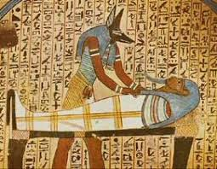
6. We will look at mummification and what the Ancient Egyptians believed happened to you when you died. (History)
2. We will look at the structure of Ancient Egyptian society. (History)
We will explore the River Nile and its importance. (Geography)

What were the lives of Ancient Egyptians like?
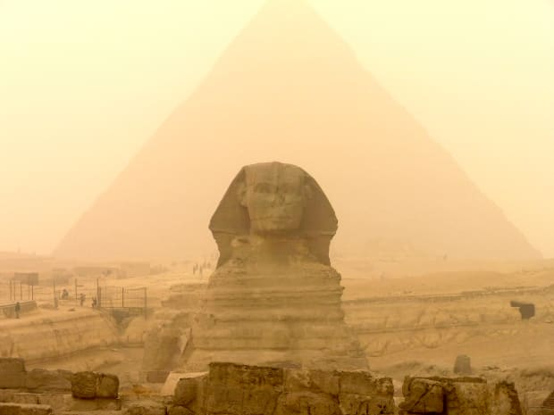
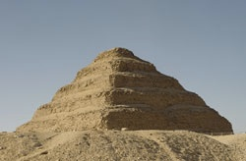
7. We will look at why and how the pyramids were built and the different kinds of pyramids through Ancient Egyptian history. (History)

5. We will look at Ancient Egyptian artefacts and think about what they can tell us about life in Ancient Egypt. (History)
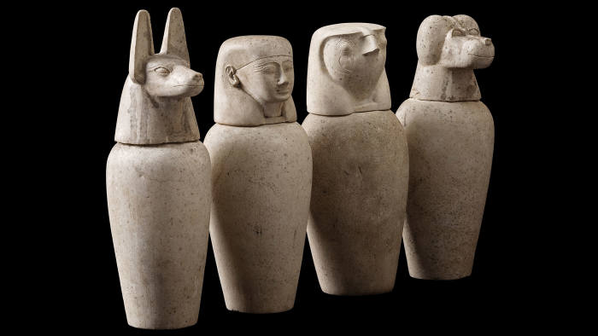
4. We will look what the Ancient Egyptian form of writing was and how it was used throughout Ancient Egyptian society. (History)
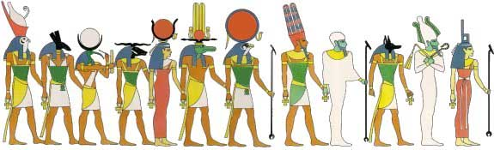
3. We will look at the gods and goddesses worshipped by The Ancient Egyptians. (RE link)

