
Y4 – Autumn 2
Animals including humans

Week 2 – Types of Teeth
To draw conclusions from an investigation about keeping teeth healthy and to identify and examine different types of teeth.
Week 1 – Tooth Decay
Identifying the different types of teeth in humas and their simple functions.
To set up a simple practical enquiry ensuring it is a comparative and fair test.



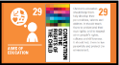
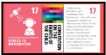
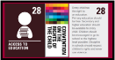
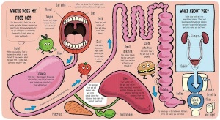
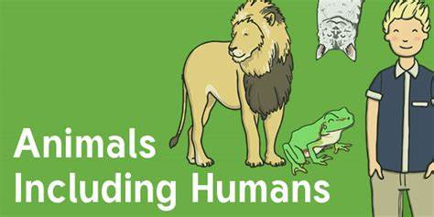
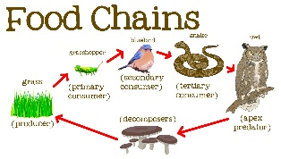
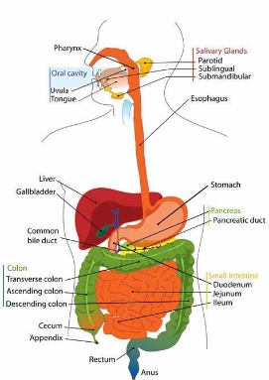
How do animals (including humans) eat and how do their bodies process food?
Week 6 – Animal Teeth
To identify differences, similarities or changes related to simple scientific ideas and processes.

Skills we will be using:
- Ask relevant questions.
- Gather, record classify and present data in a variety of ways to help in answering questions.
- Identify differences, similarities or changes related to simple, scientific ideas and processes.
- Describe the simple functions of the basic parts of the digestive system in humans.
- Identify the different types of teeth in humans and their simple functions.
- Identify that animals, including humans, need the right types and amounts of nutrition, that they cannot make their own food and they get nutrition from what they eat.
- Construct and interpret a variety of food chains, identifying producers, predators and prey.
Week 3 – Parts of the Digestive System
To describe the simple functions of the digestive system in humans.
Week 5 – Food Chains
Construct and interpret a variety of food chains, identifying producers, predators and prey.
To gather, record, classify and present data in a variety of ways to help with answering questions.

Week 7 – Assessment
Twinkl Assessment
Week 4 – The Digestion Process
To demonstrate and explain the process of digestion by using straightforward scientific evidence to answer questions or to support your findings.

