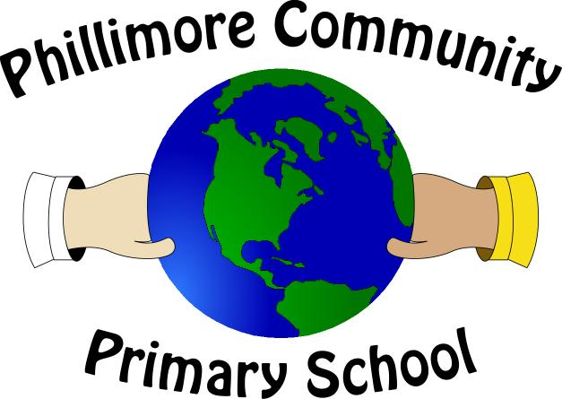
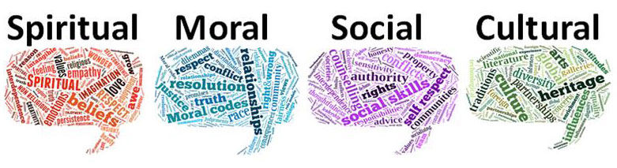

The Promotion of SMSC Development at Phillimore Community Primary
Phillimore Community Primary
SMSC
SMSC stands for Spiritual, Moral, Social and Cultural education. It is not taught as a lesson, rather it may be part of Religious Education, Physical Education, Personal, Social and Health Education AND part of the ethos of the school which children experience on a daily basis. SMSC is now highlighted by the government as a key means of promoting basic British values.

SPIRITUAL
Pupils’ spiritual development is shown by their:
- beliefs, religious or otherwise, which inform their perspective on life & their interest in & respect for different people’s feelings & values
- sense of enjoyment and fascination in learning about themselves, others and the world around them, including the intangible
- use of imagination and creativity in their learning
- willingness to reflect on their experiences
MORAL
Pupils’ moral development is shown by their:
- ability to recognise the difference between right and wrong and their readiness to apply this understanding in their own lives
- understanding of the consequences of their actions
- interest in investigating and offering reasoned views about moral and ethical issues
SOCIAL
Pupils’ social development is shown by their:
- use of a range of social skills in different contexts, including working and socialising with pupils from different religious, ethnic and socio-economic backgrounds
- willingness to participate in a variety of social settings, cooperating well with others and being able to resolve conflicts effectively
- interest in, and understanding of, the way communities and societies function at a variety of levels
CULTURAL
Pupils’ cultural development is shown by their:
- understanding and appreciation of the wide range of cultural influences that have shaped their own heritage
- willingness to participate in, and respond to, for example, artistic, musical, sporting, mathematical, technological, scientific and cultural opportunities
- interest in exploring, understanding of, and respect for cultural diversity and the extent to which they understand, accept, respect and celebrate diversity, as shown by their attitudes towards different religious, ethnic and socio-economic groups in the local, national and global communities
What are British values?
The document “Promoting fundamental British values as part of SMSC in schools” says “Schools should promote the fundamental British values of democracy, the rule of law, individual liberty, and mutual respect and tolerance of those with different faiths and beliefs”.
It is this list of values that are used below as a basis for this statement.

Democracy
- We listen to children’s and parent’s voice. Our school behaviour policy is clear that children are expected to contribute and co-operate, taking into account the views of others. Each class sees democracy in action as they elect members to represent them on the School Council. The School Council, which meets regularly with the Deputy Headteacher, chooses its officers through an election and will often vote on proposals within meetings. Pupil voice is also heard through Class Council which is fed back through School Council, class circle times, pupil interviews and class assemblies.

The Rule of Law
- We consistently reinforce our high expectations of children. Children are taught the value and reasons behind our expectations (rules) that they are there to protect us, that everyone has a responsibility and that there are consequences when rules are broken. The understanding of right and wrong is a thread that runs through school activity. It is discussed in school and class assemblies, RE, P4C and PSHE lessons. Children are supported in making good choices between right and wrong by general school rules (some of which, in classes, are democratically selected by the children themselves) and particular rules e.g. those that govern the use of play equipment. Children are continually reminded about what is needed to make a safe and happy community and the role of boundaries (rules, laws) to achieve this. To reinforce this message, visits e.g. from our Police Liaison Officer, Police Officers, and the Fire Service are a regular feature of our calendar.

Individual liberty
- Within school, children are actively encouraged to make choices, knowing that they are in a safe and supportive environment. As a school we educate and provide boundaries for young children to make choices safely, through our provision of a safe environment and empowering teaching. Children are encouraged to know, understand and exercise their rights and personal freedoms. We provide a culture, environment and opportunity for children to make their own choices, recognising the need for their own and others’ safety and well-being. This is supported by a programme of E-safety, P4C and PSHE lessons and assemblies.

Mutual respect
- At Phillimore Community Primary School we recognise that everyone is important and special, and needs to be treated as such. Our behaviour policy, our school rules, the modelling of adults and pupil leaders as well as the explicit teaching through PSHE, P4C and assemblies, actively promotes this value each week.

Tolerance of those of different faiths and beliefs
- Our school, like our country, has a richness that is due to the diversity of those who live here, and we value, embrace, and respect those from different backgrounds, cultures and beliefs. We aim to enhance children’s understanding of different faiths and beliefs by participating in a range of celebrations throughout the year. Children have the opportunity to dress-up in clothes and try different foods from other cultures during RE days.

