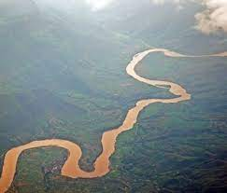
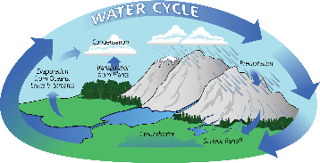
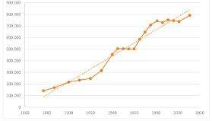

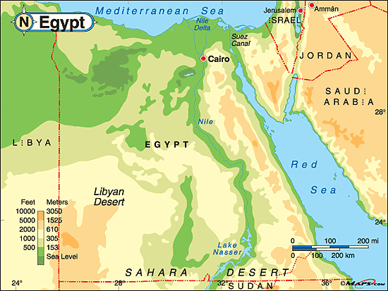
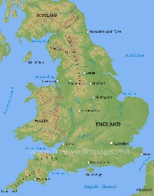
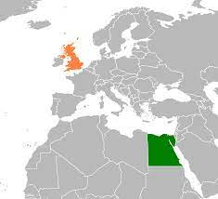
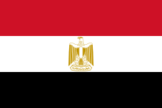

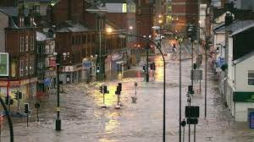

4. We will explore the water cycle with a focus on the U.K. and Egypt.
5. We will compare the populations of the U.K. and Egypt and produce a line graph to show this information.

3. We will compare the River Nile to the River Don and study the impact of flooding in Egypt and Sheffield.

1. We will be able to name rivers, mountains and other aspects of the physical geography of the U.K. and Egypt and compare the landscapes.
2. We will understand the physical features of rivers with a focus on the River Nile.

Global Theme: Identity and Diversity
Purpose
To understand how the land of Egypt is different to the United Kingdom.

- Use maps to identify the key physical and human features of a location.
- Describe key aspects of: physical geography, including: rivers, and mountains.
- Describe geographical similarities and differences between countries.
- Explain own views about locations, giving reasons.
- To understand the physical features of a river and the physical impact a river has on a location.
- To know and be able to talk about the similarities and differences between the human and physical Geography of the Nile in Egypt and waterways in Sheffield.
- Through a detailed study of Egypt’s key topographical features to study how and why land use has changed over time. Eg. Comparing land use resulting from Nile flooding with human impact of flooding in Sheffield.
- To compare the population in the UK with the populations in Egypt.

How is Egypt different geographically to the United Kingdom?

