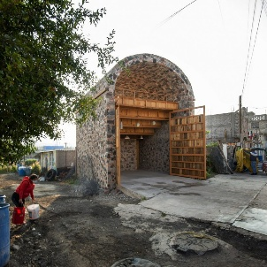

Y4 – Autumn 2
Design & Technology
Week 1 – Exploring the frame structure
To create a range of different shaped frame structures.

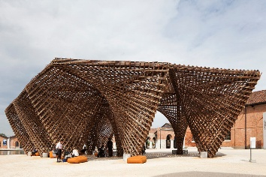
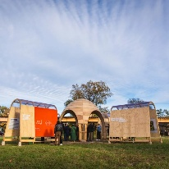

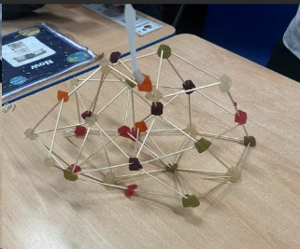
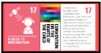
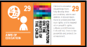
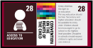
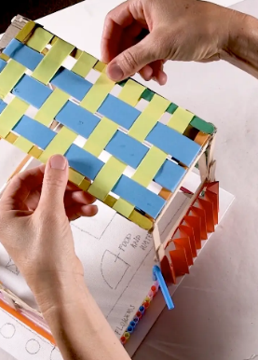
Week 3 – Pavilion frame
To build a frame structure.
Week 4 – Pavilion Cladding
To add cladding to a frame structure.

Skills we will be using:
- Designing a stable pavilion structure that is aesthetically pleasing and selecting materials to create a desired effect.
- Building frame structures designed to support weight.
- Creating a range of different shaped frame structures.
- Making a variety of free-standing frame structures of different shapes and sizes.
- Selecting appropriate materials to build a strong structure and for the cladding.
- Reinforcing corners to strengthen a structure.
- Creating a design in accordance with a plan.
- Learning to create different textural effects with materials.

Structure Pavilions
Week 2 – Designing a pavilion
To design a structure.

