
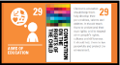
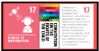
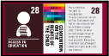

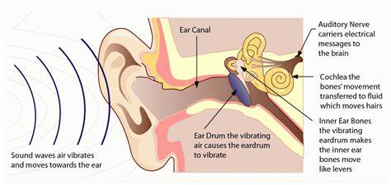


How do we hear sounds and what makes a sound loud or quiet or high and low?
Global Theme: Sustainable Development

5
1). Assessment
2). We will use what we know about sound travelling through vibrations to make our own string telephone.

4
We will use our understanding that sound needs to travel through something to investigate how we can absorb sound.
We will find out why some materials absorb sound better than others.

Y4 – Spring 1
Sound

1
We will be identifying sources of sound and how sources of sound vibrate, creating sound.

2
We will be looking at how vibrations change when a sound gets louder and will be able to explain how sound gets to our ears.
3
We will be looking at high and low sounds and observing the patterns between the pitch of a sound and features of the object that made the sound.
We will explore how to change the pitch of an instrument depending on its features.
Skills we will be using:

- Ask relevant questions.
- Gather, record classify and present data in a variety of ways to help in answering questions.
- Identify differences, similarities or changes related to simple, scientific ideas and processes.
- Identify how sounds are made, associating some of them with something vibrating.
- Recognise that vibrations from sounds travel through a medium to the ear.

