Lesson 3: Pavilion Frame
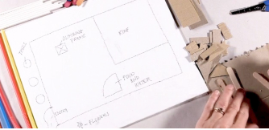
Using their designs and a range of materials, children will build a strong frame structure for their pavilion.
Learning Objective: to build a frame structure.
Lesson 4: Pavilion cladding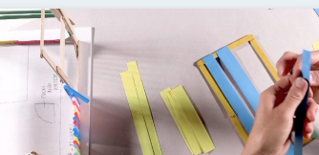
Experimenting with different decorative techniques, children will use paper and other materials to clad their pavilions,

Lesson Objective: to add cladding to a frame structure.

Key concepts
This concept involves developing the process of design thinking and seeing design as a process.

Lesson 2: Designing a pavilion
Using their knowledge from lesson 1, children will design their pavilion structure.
Learning Objective: to design a structure.
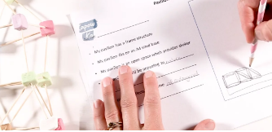

Lesson 1: exploring frame structures
Using toothpicks and plastcine, pupils explore different frame structures to test which ones are the most stable.
Learning Objective: To create a range of different shaped frame structures
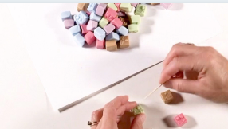

How can structures be equitable for all of society? Focus: Social Justice and Equity

