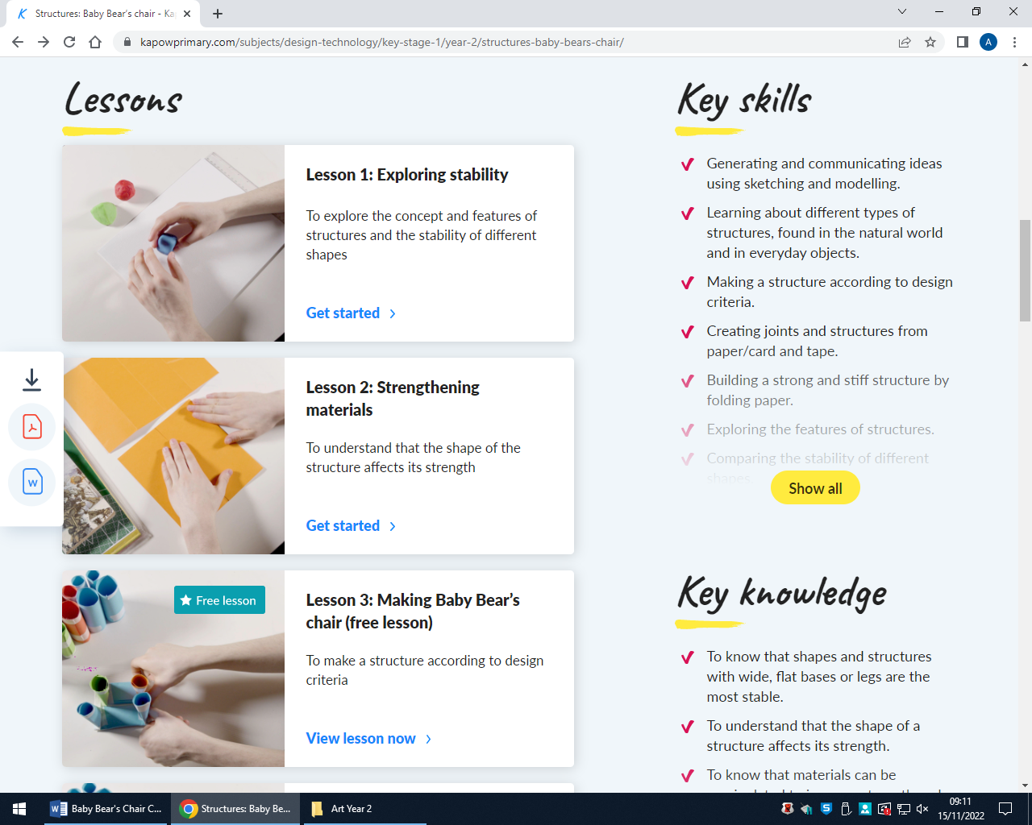
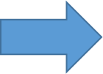
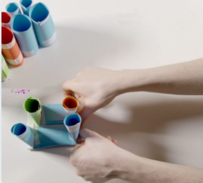
- 2. We will explore strength in different structures. We will understand that the shape of the structure affects its strength.

Design and Technology: Autumn 2
1. We will explore the concept and features of structures and the stability of different shapes.

3. We will make a structure according to design criteria.
4. We will produce a finished structure and evaluate its strength, stiffness and stability.
Purpose: To make a chair for Baby Bear that is Strong, Stiff and Stable and can support his mass.
Peace and Conflict

