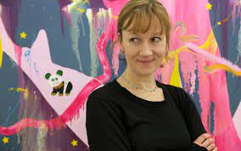
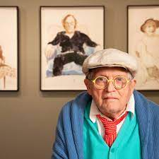
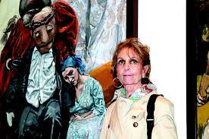
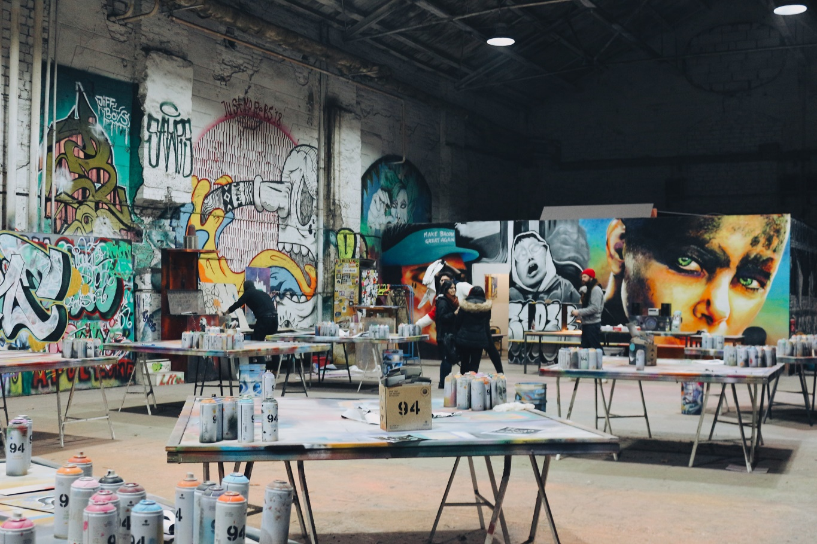
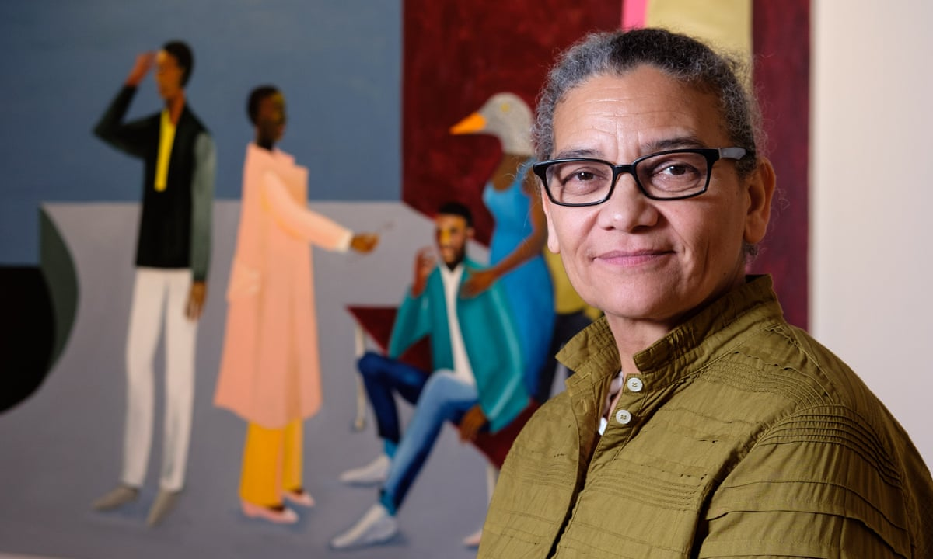
Art. Year 6 Spring 1. Painting & Mixed Media: Artist Study

Lesson 3: Fiona Rae
To apply interpretation skills to analyse and respond to an abstract painting

Global theme: Sustainable Development
Key Concepts:
- Suggest ideas for the meaning behind a picture.
- Identify different features within a painting and use the formal elements to describe it.
- Be creative and imaginative in finding their own meaning in a painting.
- Reflect on personal experiences to convey through their own piece of abstract art.
- Understand and choose a meaningful message to convey through imagery, creating some different composition ideas.
- Collect a range of information that is presented in an interesting and pleasing way in sketchbooks.
- Generate an idea for a final piece, demonstrating some inspiration from their chosen artist.
- Produce a final piece of work, selecting appropriate tools and materials to create an intended effect.
- Experiment and revisit ideas, drawing on creative experiences.
- Work in a sustained way to complete a piece, making evaluations at each stage.

Lesson 6: Making art!
To demonstrate an understanding of painting techniques to make personal choices

Lesson 5: Research and planning
To develop starting points for creative outcomes

Lesson 4: Lubaina Himid
To understand how art can tell stories or portray messages

Lesson 1: David Hockney
To understand how to analyse a famous painting

Lesson 2: Paula Rego – The Dance
To understand how to find meaning in painting

