Lesson 5: Still life
Learning Objective: To apply knowledge of colour mixing and painting techniques to create a finished piece.
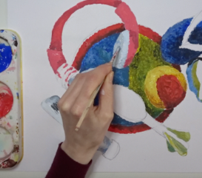

Lesson 4: Composition
Learning Objective: To consider proportion and composition when planning a still-life painting
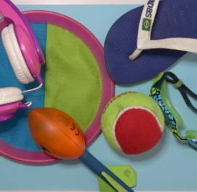

Lesson 3: Painting techniques

Learning Objective: To explore how paint can create very different effects.
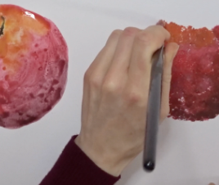

Lesson 2: Three dimensions

Learning Objective: To use tints and shades to give a three-dimensional effect when painting.
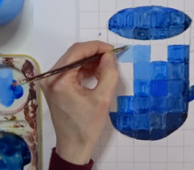

Lesson 1: Tints and shades
Learning Objective: To investigate different ways of applying paint. To mix tints and shades of a colour.
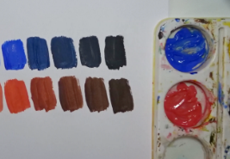
Year 4 Painting and mixed media
Key concepts: Children learn more about the effect of light on colour in everyday life and in art. Applying what they learned previously, they paint a simple object, mixing and using tints and shades to give the appearance of three dimensions.
.

