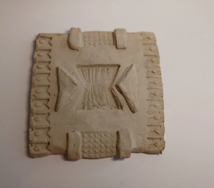
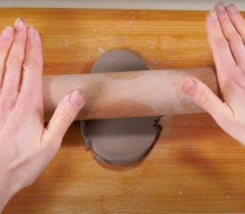
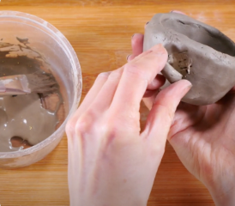
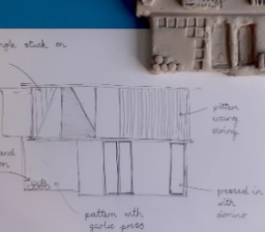
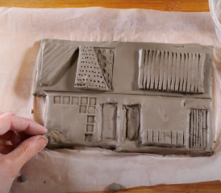
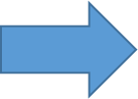
Purpose: To make 3D clay tile to be shared as part of a gallery.
1. We will learn to shape clay using our hands. We will flatten clay to make a smooth surface, shape clay with our hands, make different marks by pressing into the clay and we will shape clay to make a model.

- 5. We will make a 3D clay tile from a drawn design. We will use both pressing in and joining clay techniques on the tile. We will then evaluate the finished tile and say how it reflects the design

- 4. We will use drawing to plan the features of a 3D model. We will draw and label a house that will be made into a clay tile and decide how to create features like a door, windows and the roof.
- 3. We will use impressing and joining techniques to decorate a clay tile. We will discuss the work of artist Rachel Whiteread. We will roll a smooth clay tile and create a pattern by pressing into and joining pieces onto my tile.

2. We will learn to shape a pinch pot and join clay shapes as decoration. We will use a pinching technique, use our fingers and thumbs to make the sides even and join the clay to help decorate the pot.

Art and Design: Spring 1
Identity and Diversity

