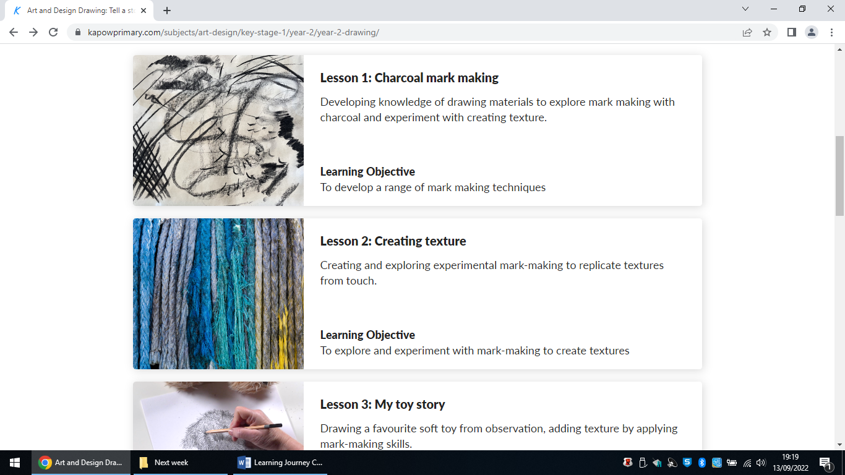

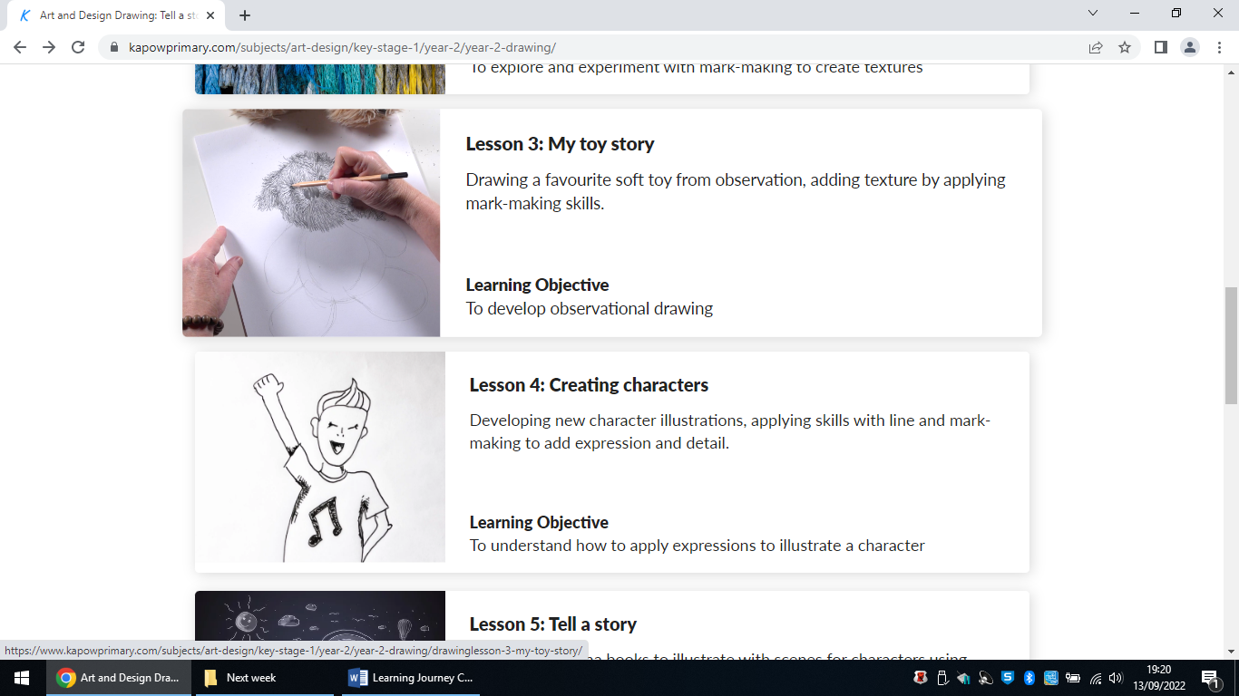
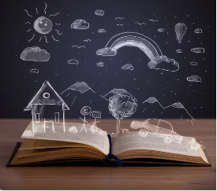
1. We will develop our knowledge of drawing materials to explore mark making with charcoal and experiment with creating texture.

Social Justice and Equity
Purpose: To make a concertina book to be shared with children from another class.
Art and Design: Autumn 1
5. We will learn to make concertina books to illustrate with scenes for characters using mark-making drawing techniques.
4. We will learn to develop new character illustrations, applying skills with line and mark-making to add expression and detail.
3. We will learn to draw a favourite soft toy from observation, adding texture by applying mark-making skills.
2. We will create and explore experimental mark-making to replicate textures from touch.

