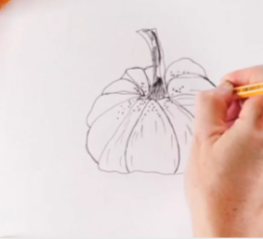
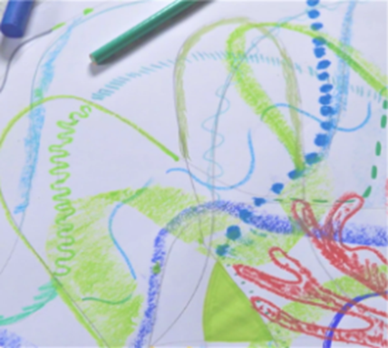

- We will look at the works of Bridget Riley, as a stimulus to draw a variety of lines using pencil and chalk in our sketch books.
5. We will apply our skills and knowledge to create an observational drawing piece that allows them to experiment with marks, materials and shows good observation
To explore line and mark-making to create an observational drawing.
We will be looking at the works of Bridget Riley, Zaria Forman, Renata Bernal, Wassily Kandinsky and Ilya Bolotowsky.

Observational drawings- linked to science, plants
2. Inspired by the work of Zaria Forman, we will continue to explore lines in art in a more expressive way. We will listen to music to draw lines and waves to reflect what we hear and create a water collaboratively.
4. We are exploring mark making through observational drawing, developing an understanding of techniques and learning to look carefully when drawing.
6. We will evaluate our pieces of artwork saying what we have done well and what we could do to improve it.
3. Inspired by the famous abstract artists, including Kandinsky, children draw around and overlap 2D shapes to create an abstract composition.
Art
Autumn 2

