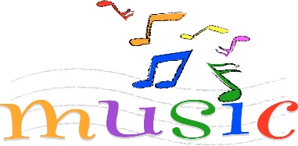

Week 2 –
Rock Around the Clock
To be able to perform with a sense of style.

Week 1 –
Hand Jive
To understand the history of rock and roll music.

Y4 – Music
Spring 1
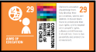
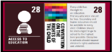


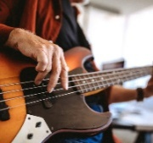


Rock and Roll
Global Theme: Sustainable Development
Pupils who are secure will be able to:
- Perform the hand jive hand actions in sequence and in time with the music.
- Sing in tune and perform their actions in time.
- Play the notes of the walking bass in the correct sequence.
- Independently play their part with some awareness of other performers.
Week 6 –
Consolidation of unit
Week 5 –
Rock and roll performance
To be able to play a rock and roll piece of music.

Week 4 –
Performing the bass
To be able to play a rock and roll bass line.

Week 3 –
Walking bass line
To play a walking bass line on tuned percussion.

