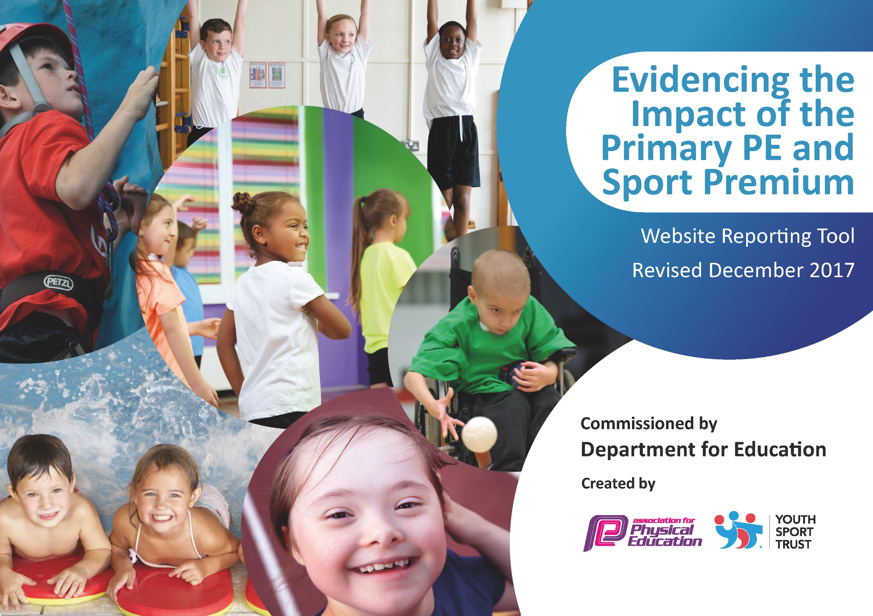
c

Schools must use the funding to make additional and sustainable improvements to the quality of PE and sport they offer. This means that you should use the Primary PE and Sport Premium to:

- develop or add to the PE and sport activities that your school already offers
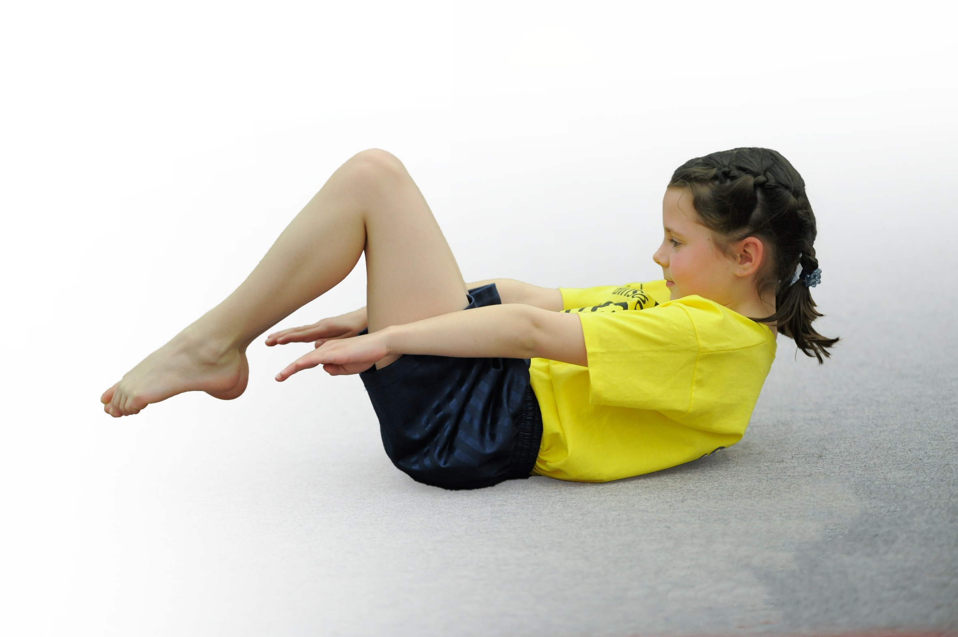
- build capacity and capability within the school to ensure that improvements made now will benefit pupils joining the school in future years

Please visit gov.uk for the revised DfE guidance including the 5 key indicators across which schools should demonstrate an improvement. This document will help you to review your provision and to report your spend. DfE encourages schools to use this template as an effective way of meeting the reporting requirements of the Primary PE and Sport Premium.

We recommend you start by reflecting on the impact of current provision and reviewing the previous spend.
Under the Ofsted Schools Inspection Framework, inspectors will assess how effectively leaders use
the Primary PE and Sport Premium and measure its impact on outcomes for pupils, and how effectively governors hold them to account
for this.

Schools are required to publish details of how they spend this funding as well as on the impact it has on pupils’ PE
and sport participation and attainment.
We recommend regularly updating the table and
publishing it on your website as evidence
of your ongoing review into how you are using the money
to secure maximum, sustainable impact. To see an example of how to complete the table please click HERE.

Support for review and reflection - considering the 5 key indicators from DfE, what development needs are a priority for your setting and your students now and why? Use the space below to reflect on previous spend, identify current need and priorities for the future.

Key achievements to date: | Areas for further improvement and baseline evidence of need:
Engagement of all pupils in regular physical activity – kick-starting healthy active lifestyles: 2016/17 Fit4Schools programme test results demonstrate impact on fitness levels:  - Overall school improvement 17.76%  - Girls’ improvement 20.96%  - Boys’ improvement of 14.81%  - Pupil Premium improvement 20.88%  - EAL improvement 20.95%  - SEN improvement 22.77%  Pupils, staff and parents/carers more fitness aware. Staff include fitness focus in every PE lesson warm up; £50K spent on playground make over (including an extra £2K on cycling  pods) and playtimes more active with MDS and Y5 playground leaders involved; increased number of school clubs and opportunities to compete in Level 2 competitions. KS1 and Y3 pupils’ fitness levels now above national average nation. School awarded Centre of Excellence by Yorkshire Sport for work and initiatives on improving health and well being of all pupils. Staff adopt increased physical activity in the form of ‘Activate’ and the ‘Daily Mile’ following a staff meeting with the focus on the importance of greater cardio respiratory fitness. Pupil comment: ‘The daily mile makes my brain come alive’  Programme of Food Education includes nutrition, cookery skills and links to increasing physical activity. Links made with outside agencies: WhyWeight, Darnall Wellbeing, SchoolYard Challenge, School Swimathon. | Continue to monitor pupils’ attitudes to fitness and health and ensure links are made with  improved attainment, behavior and attendance.  All adults with a responsibility for improved pupil outcomes (staff, parents/carers) continue to be aware of impact they can have on improving health and associated attitudes.  Work still to be done with KS2 pupils regarding fitness levels.  Continuous monitoring of PE lessons to ensure references made to health and at least 80% of lesson is constructive physical activity for all pupils regardless of ability or disability.  Questionnaire to ascertain pupil voice on attitudes to fitness.  Identification of inactive pupils to create target groups for future investment.  Identification of non traditional activities which will increase pupils’ fitness and engage them in a lifelong love of sports and physical activity eg GoRideGo programme of cycling from Balance Ability to competition; Climbing and Bouldering; Paralympic sports eg Sitting Volleyball, Boccia, Goal Ball and Curling.
Profile of PE and sport raised across the school as tool for whole school improvement  PE and school sport is linked to attainment on the school development plan. All pupils make progress in every lesson. All pupils receive at least 2hrs of PE per week. Increased understanding of the link between health and lifestyle/diet and whole school improvement. PE used to rubber stamp school ethos/secrets of success and school curriculum drivers with whole school assemblies to celebrate success through sport links made to hard work, never giving up, etc.  Staff meetings held with PE focus.  Three parents’ meetings held on health and fitness at Phillimore.  Worked with ‘WhyWeight’ (commissioned by SCC) to deliver Y4 lessons on nutrition.  Worked with school meal provider Taylor Shaw to pilot pupil cookery classes. | Develop a school friendly PE assessment system which is standardised across the school and which informs parents, teachers, support staff and secondary schools covering the wider aspects of the Physical Education programme (physical, social, cognitive, creative, healthy). Lead staff meetings in assessment.  Lesson observation: Focus on ‘Secrets of Success’ observed in 100% of lessons. Fitness focus observed in 100% of PE lessons. Focus on AfL observed in 100% of lessons. Ensure all lessons are inclusive and all pupils make progress.  Promote the importance of physical activity on learning so that all lessons inclusive and vigorously active. Investigate Active Maths/Active Literacy/Active Science/IMOVES.  Use data from Fit4schools programme to inform school governors of need to improve fitness and make links with WSI.
Increased confidence, knowledge and skills of all staff in teaching PE and sport  FS2, KS1 and Y3 staff training in fundamental skills with own classes using 4 coloured boxes of equipment with resulting improved physical literacy at KS1 and Y3. Raised confidence and competence in teaching in PE. Staff deliver high quality PE lessons. School SEF includes accurate information on teaching and learning in PE. Ongoing programme of targeted CPD (Gymnastics and Cricket in Y5, Gymnastics in Y4 and Y3; Dance and Gymnastics in Y2 and Y1; Balance Ability in FS2)  Whole staff training on physical development milestones and use of the Primary Spaces area using Skills2Play and Start to Move.  Lesson observations with feedback for staff development. | Increase confidence in assessment in PE by developing whole school system.  Continue programme of observations in PE lessons with focus on use of planning; fitness (vigorous activity); fundamental skills in KS1 and Y3. Feedback to SLT.  Improved fitness observed in at least 80% of pupils at playtime using the Schoolyard Challenge fitbits.
Broader experience of a range of sports and activities offered to all pupils  Improved numbers of pupils participating in ex-curricular activities. Improved numbers of staff feeling confident to offer ex-curricular activities. Broader range of activities offered. Worked with local universities to boost curriculum and after school activities. Offered Bike Ability (x30 level 2 achieved) and Balance Ability (all FS2 assessed). 60 First Aid pupils trained and 2 champions selected and trained further. | Increase number of school clubs advertised on school website from previous year. Increase number of different sports and activities including Paralympic sports offered to pupils either through the curriculum or after school. Continue to inc % from non riders to riders. Continue to seek competition for pupils not yet rep school see PE Profiles for pupils’ comments. Target Y2 for skipping workshops and competition; Y3 outdoor learning in including weaseling; Y4?; Y5 ESCAPE project with climbing/walk in Peaks and residential; Y6 African Dance workshop and swimming top up
Increased participation in competitive sport  Improved numbers participating in competitive sport through specific targeting (eg Sitting Volleyball through to level 3 competition at South Yorkshire finals 15 ch representing Phillimore and Sheffield; Curling 6 ch won gold; Sportshall Athletics 24 ch through to last 8, City finals; Outdoor Athletics 8 ch through to City Finals). | Ensure staffing/transport to enable pupils to continue to participate in inter school sports, festivals and competition. Develop tracking system of pupils participation in competitive sport both intra and inter to enable specific targeting.

Meeting national curriculum requirements for swimming and water safety | Please complete all of the below*:
What percentage of your current Year 6 cohort swim competently, confidently and proficiently over a distance of at least 25 metres? These results reflect the current cohort of Y6s when they were Y4s in 2015/16 | 81.8 %
What percentage of your current Year 6 cohort use a range of strokes effectively [for example, front crawl, backstroke and breaststroke? These results reflect the current cohort of Y6s when they were Y4s in 2015/16 | 18.1%
What percentage of your current Year 6 cohort perform safe self-rescue in different water-based situations? These results reflect the current cohort of Y6s when they were Y4s in 2015/16 | 0%
Schools can choose to use the Primary PE and Sport Premium to provide additional provision for swimming but this must be for activity over and above the national curriculum requirements. Have you used it in this way? | Yes/No
*Schools may wish to provide this information in April, just before the publication deadline.

Action Plan and Budget Tracking
Capture your intended annual spend against the 5 key indicators. Clarify the success criteria and evidence of impact that you intend to measure to evaluate for students today and for the future.

Academic Year: 2017/18 | Total fund allocated: £19,540 | Date Updated: 1/1/18
Key indicator 1: The engagement of all pupils in regular physical activity – Chief Medical Officer guidelines recommend that primary school children undertake at least 30 minutes of physical activity a day in school |  |  |  | Percentage of total allocation:
 |  |  |  | 28.48%
School focus with clarity on intended impact on pupils: | Actions to achieve: | Funding allocated: | Evidence and impact: | Sustainability and suggested next steps:
Develop Balance Ability for all FS2 pupils to increase their PA and improve their fundamental skills.  Develop Y3 Walking programme to encourage pupils to walk more in their locality  Develop Daily Mile for Y6s each day  Continue programme of fitness testing with data and targeted support for all pupils  Develop sustainable travel to school by working with SUSTRANS to reduce numbers of families using cars  Create spreadsheet to enable targeting of inactive pupils and evidence based documentation  Increase activity using the new playground and the Schoolyard Challenge fitbits in KS2  Investigate holiday clubs due to decrease in fitness levels after holiday periods  Also Hunger clubs - SCC | - Employ additional teacher to work alongside members of staff to upskill  - Purchase 10 balance bikes including some for taller pupils.  - Ensure all helmets are safe and replace those that are not  - Employ additional teacher to lead, develop and work alongside members of staff to upskill  - Create maps as resources  - Work with Y6 staff to ensure Daily Mile is carried out each day and is purposeful  - Book Fit4Schools  - Analyse data and feedback to staff, pupils and parents/carers to enable and encourage further spotlight on fitness and physical activity  - Work with SUSTRANS to develop programme  - Admin time  - Create timetable and set up website for each class to record data  - Admin time | £480  £700  £50  £825  £30  £0  £2,949.99  £231  £150  £150  £0 | Fewer pupils unable to ride a bike when reach Y4 at start of assessment for Bike Ability.  More parents involved in helping to develop this life skill by buying bikes and helping their children to learn to ride.  See Pupil Voice feedback as Y3s enthusiastic about programme  See also staff feedback  More Y6s power walking or jogging for the 15 mins so increasing their additional PA each day  All stakeholders aware of the disparity between Phillimore pupils and national averages. Programmes in place to combat and improve fitness levels.  Through to last 8 in Sheffield City Athletics finals 2018 (poor fitness 4 years ago sparked off concern to find initiatives to improve)  Fewer pupils coming to school by car. Roads safer around school and improved local environment  Have evidence base for targeting pupils and selecting broader range of physicalactivities
  Increased activity and excitement
  for the year group using the fitbits
  (one year group per day). Pupils
  very disappointed when the fitbits
  had to be returned so other schools
  could use. Gave positive feedback
  to MoveMore to enable further
  development of programme.
  WIDER IMPACT AS A RESULT OF
  ABOVE
  Pupils more active in PE
  Lessons and take part without
  stopping to rest.
  Standards achieved in PE NC are
  improving with over 95%
  achieving end of KS attainment
  target
  Attitudes to learning
  improved with better concentration
  in lessons.
  SAT results improved/floor targets
  met – see data.
  Continue to work closely with parents/carers to increase numbers of pupils owning bikes
  Daily mile firmly embedded and used in other year groups + benefits understood
  SLT aware of the significance and continue programme once SP funding finishes
  Increased understanding about pupil safety and fitness levels so change in mindset of parents and carers
  Work with pupils, staff and parents/carers
  Sign up again when programme offered by MoveMore
  Current total: £5,565.99
Key indicator 2: The profile of PE and sport being raised across the school as a tool for whole school improvement |  |  |  | Percentage of total allocation:
 |  |  |  | 6.82%
School focus with clarity on intended impact on pupils: | Actions to achieve: | Funding allocated: | Evidence and impact: | Sustainability and suggested next steps:
Attendance by PE co-ordinator and Head teacher at Sheffield PE Conference in September 2017  Attendance at local and national initiatives to promote PE and school sport including school swimming  Celebration days and assemblies to ensure whole school aware of importance of PE and Sport and to encourage all pupils to aspire to being involved. Sporting heroes to attend  Open Afternoons for parents/carers/ other schools in area on PE, school sport, health, PA, Dance Sharing and links to WSI  Presentation to Governors  Active Maths  Active Literacy  Active Science  Imoves | - Book and attend  - Follow up Active Maths  - Plan and attend  - Feedback to Locality Heads  - Plan and lead  - Book Jonnie Peacock and Ellie Simmonds  - Achievements celebrated in assembly (match results + notable achievements in lessons etc)  - Classes to demonstrate to dance/gymnastics displays.  - Book HD and BK on training at Thornbridge | £50  £399  £231  £231  £423 | Headteacher inspired by workshops on active learning and keen to start Active Maths in school.  Headteachers in Locality C support attendance and value the continued update in these areas.  All pupils at some point in the year have taken part in assemblies and celebration days. See written feedback by pupils  WIDER IMPACT AS A RESULT OF ABOVE  Pupils proud to be involved in celebration days/assembles/photos on notice boards etc. which is impacting on confidence and self esteem.  See notes in Indicator 1 about attendance and attitudes to learning with better performance in SATs. There are over 30 pupils attending clubs in the community which is complimenting activities in school and in the curriculum.  Increased self esteem/confidence are having an impact on learning across the curriculum. | SLT aware of benefits of the raised profile and is committed to funding these areas if the Primary PE and Sport Premium is discontinued.  Current total: £1,334

 | Key indicator 3: Increased confidence, knowledge and skills of all staff in teaching PE and sport |  |  |  |  |  |  |  |  | Percentage of total allocation:
 |  |  |  |  |  |  |  |  |  | 30.76%
 | School focus with clarity on intended  impact on pupils: |  | Actions to achieve: |  |  | Funding  allocated: |  | Evidence and impact: |  | Sustainability and suggested  next steps:
 | Increase confidence and competence for all staff to deliver high quality PE and to extend their subject knowledge. This will over time improve progress and achievement of all pupils and increase their opportunities to engage in after school clubs that appeal to them and encourage them to take up sport for life. Observe PE lessons and/or team teaching and use of agreed ‘outstanding’ lesson criteria.  The following CPD will take place:  Y2, Y3 Dance  Y1, Y2, Y3, Y5 Games  Y2, Y3, Y4 Gymnastics  Outdoor Learning x2 members of staff (FS2 and Y3)  Develop outdoor PE lessons so pupils and staff can distinguish between playtimes and PE lessons  Y1, Y2, Y3, Y5 outdoor lessons  Active Literacy  Balance Ability training  Skipping training  Lesson observations |  | - Baseline pupils so that impact can be measured over time  - Book specialist teachers and coaches/supply  - Create timetable  - Observe PE lessons, write reports and deliver feed and identify further need for staff development |  |  | £750 + £750  £860  £1,248  £230  £860  £96  £168  £126  £924 |  | Specialist teachers and subject co-ordinator to lead professional learning for all staff with increased confidence and improved quality of teaching.  Subject co-ordinator observe PE lessons and provide effective feedback to lead discussions on staff developmental need.  WIDER IMPACT AS A RESULT OF ABOVE  Skills, knowledge and understanding of pupils are increased significantly - see note about end of key stage attainment targets  All pupils enjoy PE and Sport and are keen to take part demonstrating a real desire to learn and improve  Improved standards in invasion games in curriculum time |  | This will lead to sustainability as all staff will be supported to feel confident to deliver PE and Sport both within and outside the curriculum.  Current total: £6,012
 | Key indicator 4: Broader experience of a range of sports and activities offered to all pupils |  |  |  |  |  |  |  |  | Percentage of total allocation:
 |  |  |  |  |  |  |  |  |  | 18.16%
 | School focus with clarity on intended  impact on pupils: |  | Actions to achieve: |  |  | Funding  allocated: |  | Evidence and impact: |  | Sustainability and suggested  next steps:
 | Continue to offer a wider range of activities both within and outside the curriculum in order to get more pupils involved.  Focus particularly on those pupils who do not take up additional PE and Sport opportunities.  Athletics club – training + coach  Curling  Peak District travel  Sitting volleyball  Lacrosse club  Y5 Locality C Swimming Festival  Dance/Yoga Club  Y6 African dance workshops  Climbing comp  Y5 Climbing activity @£9 per ch and Transport  Y5 Peak walk and staff transport  Y3 Weasling JS  Staff transport  Thornbridge instructor |  | - Take up all offers from universities to run OHL clubs  - Carry out a pupil survey to ascertain what pupils would like  - Involve external coaches to work with staff in clubs |  |  | £280  £0  £17  £0  £231  £240  £500  £230 + £96  £540  £396  £248 + £20  £231  £20  £500 |  | 6 more staff involved in extra- curricular activities and all teachers feel more confident teaching new activities.  Aim to start 4 new clubs (lacrosse, table tennis, cycling, girls football) now running with an uptake of over 120 pupils (with at least 50% new attendees from last year).  WIDER IMPACT AS A RESULT OF ABOVE  Behaviour improved particularly at lunch times which has led to improved learning in afternoons  Very few instances of pupils not bringing kit to school and as a result progress and achievement in curriculum PE is good.  95% of pupils say they enjoy PE and Sport and want to get involved in more activities.  Pupils who were disaffected in school are now engaged and want to take part |  | Staff work together and share good practice which will lead to better confidence all round and more staff keen to get involved ensuring extra activities will continue.  The school no longer dependent on external 'experts' coming in to teach PE and Sport as staff more confident.  Current total: £3,549
 | Key indicator 5: Increased participation in competitive sport |  |  |  |  |  |  |  |  | Percentage of total allocation:
 |  |  |  |  |  |  |  |  |  | 9.71%
 | School focus with clarity on intended  impact on pupils: |  | Actions to achieve: |  |  | Funding  allocated: |  | Evidence and impact: |  | Sustainability and suggested  next steps:
 | Introduce additional competitive sports identified by pupils in recent survey in order to engage more.  Engage more girls in inter/intra school teams particularly those who are disaffected.  Curling – team of 6  Athletics – team of 23  Gymnastics – team of 20  Rowing – team of 8  Sports Journalism – team of 10  Climbing – team of 12  Transport to competitions where needed:  Athletics heats  Athletics City Finals finals  Gymnastics  Hire of local sports centre to enable training  Medals for Curling success  Medals for reaching City Athletics finals  Y2 skipping training and competition |  | - Identify staff members to develop Y5/6 girls football team  - Work with parents/carers so training does not interfere with other commitments (eg attendance at mosque)  - Arrange friendly competition - inter/intra school with Oasis and High Hazels via Links SSP  - Ensure all coaches have level 2/3 PESSPA qualifications  - Organise staffing for competitions  - Book and arrange |  |  | £84  £0  £0  £0  £231  £96 + £96 + £231  £294  £98  £124  £86.66  £12  £46  £500 |  | KS2 attendance at OHL clubs: 58.75%  KS2 Girls attendance at OHL clubs: 51.66%  KS2 Boys attendance at OHL clubs: 60.83%  Y3 attendance at OHL clubs: 46.66%  Y4 attendance at OHL clubs: 51.66%  Y5 attendance at OHL clubs: 71%  Y6 attendance at OHL clubs: 70%  Higher number of girls now attend Athletics club (over taken number of boys – 1st time ever)  35 girls involved in practices  20 girls played 4 matches against local schools.  WIDER IMPACT AS A RESULT OF ABOVE  Improved standards in Athletics and Gymnastics in curriculum time.  More girls keen to take part with a noticeable difference in attitudes to PE and sport.  Improved integration of pupils from minority ethnic backgrounds  Parents/carers showing more interest in PE and sports |  | Member of staff (SB) to create and take charge of girls’ football  The above member of staff to attend Level 2 FA coaching course  Current total: £1,898.66
 | Other Indicator identified by school: Additional Swimming Percentage of total allocation: N/A
 | Increase attainment of existing Y6 swimmers by 10m so improving their water confidence and therefore safety.  All remaining non swimmers achieve 25m meeting statutory requirements of NC for PE.  All pupils can perform safe self rescue over a varied distance so confident and safe in water.  All pupils to demonstrate a range of strokes effectively. |  | - Renegotiate additional pool space over a term or plan for a suspended time table week for a 5 day swimming focus  - Staff attend Swim England  professional learning  swimming teachers course to  assist with lessons |  |  | £3,600 |  | 68% of pupils can swim over 50 metres.  100% of pupils increased their distance swimming by 10 metres.  95% of pupils can swim 25 metres at year 6.  - 95% of pupils can rescue a peer from 5 metres to 50 metres.  95% demonstrate a range of effective strokes. |  | -The Governors have agreed to ensure that they will ring fence funding to ensure the maximum amount of pupils leave the school being able to swim 25m.  Where appropriate SEND funding will be allocated to non swimmers.  All staff involved are confident and secure in teaching swimming.
- |  | -

