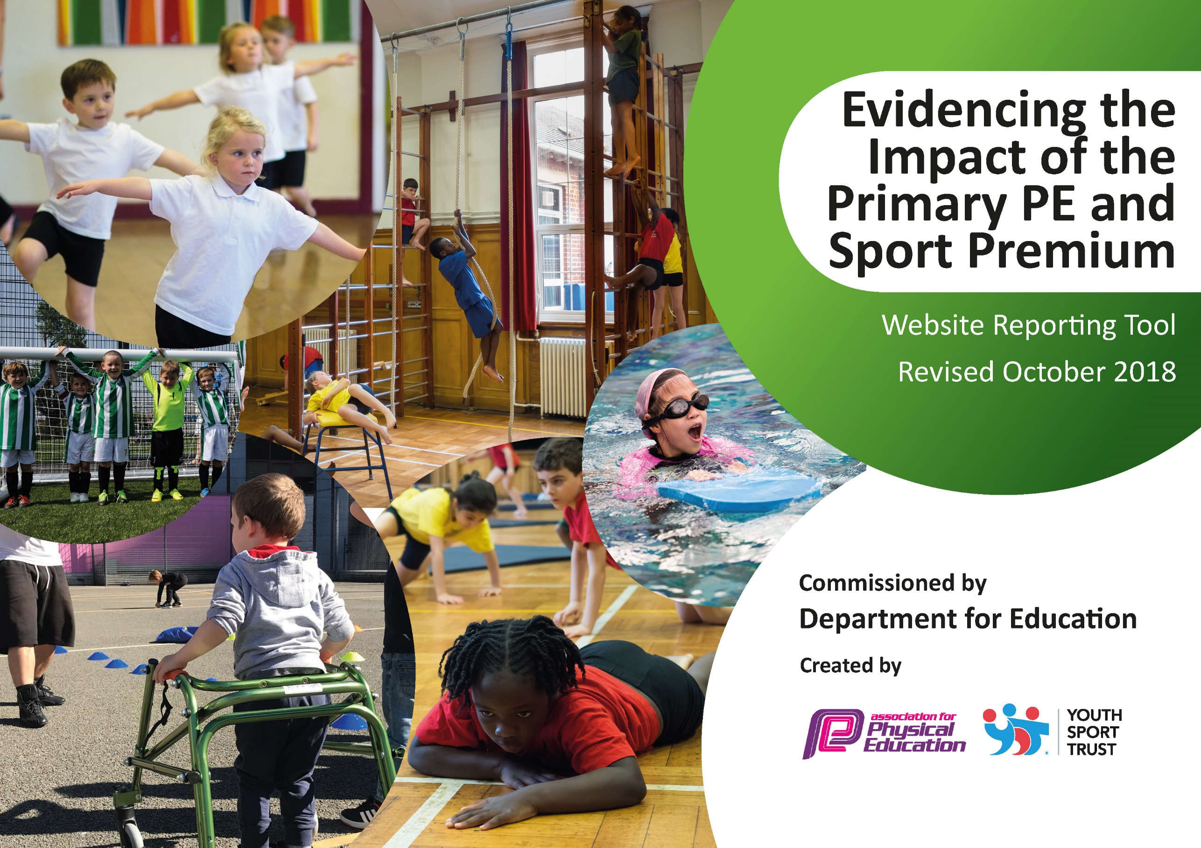
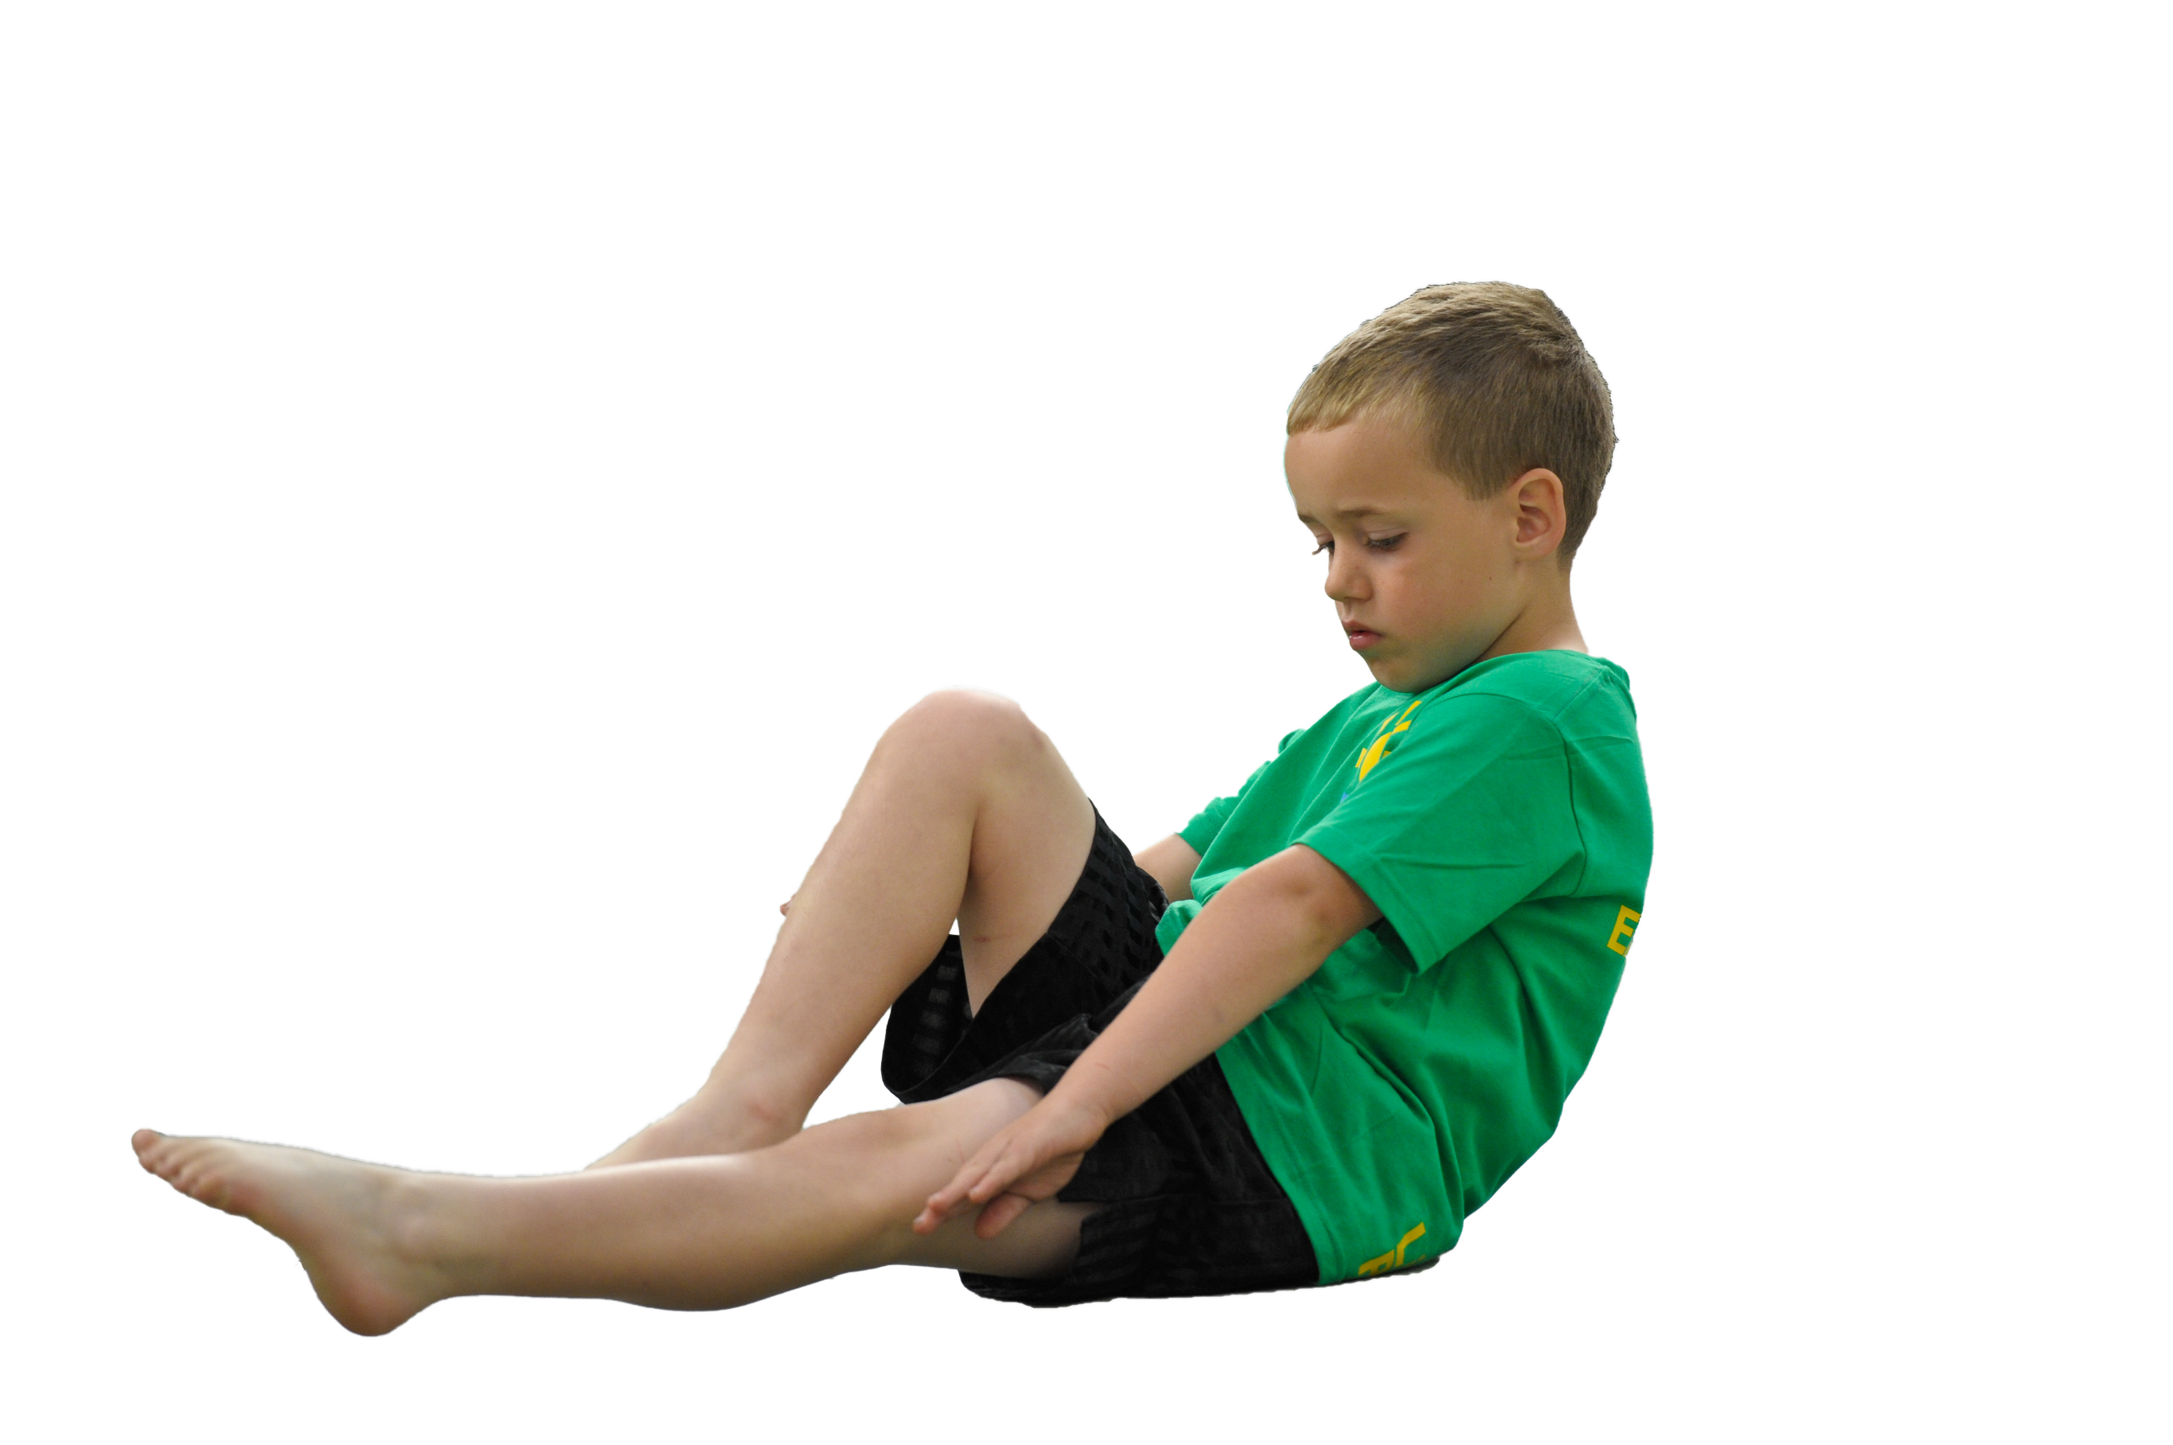
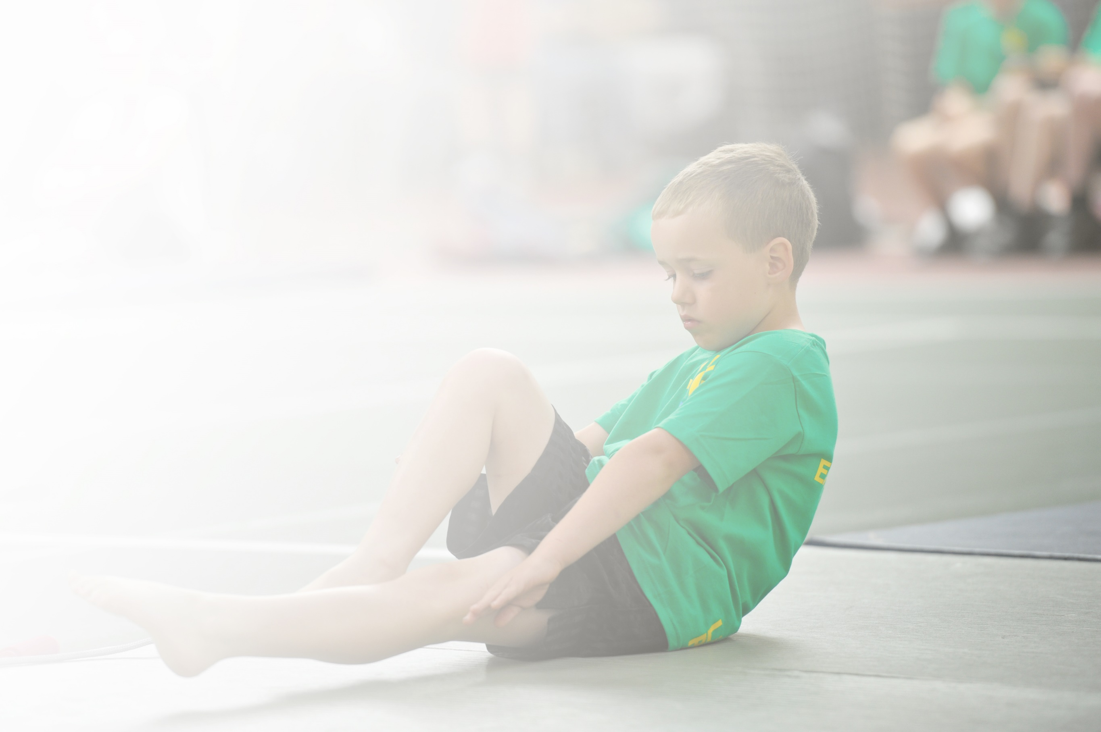
Schools must use the funding to make additional and sustainable improvements to the quality of Physical Education, Sport and Physical Activity (PESPA) they offer. This means that you should use the Primary PE and Sport Premium to:

- Develop or add to the PESPA activities that your school already offer
- Build capacity and capability within the school to ensure that improvements made now will benefit pupils joining the school in future years

Please visit gov.uk for the revised DfE guidance including the 5 key indicators across which schools should demonstrate an improvement. This document will help you to review your provision and to report
your spend. DfE encourages schools to use this template as an effective way of meeting the reporting requirements of the Primary PE and Sport Premium.

We recommend you start by reflecting on the impact of current provision and reviewing the previous
spend. Under the Ofsted Schools Inspection Framework, inspectors will assess how effectively leaders use the Primary PE and Sport Premium and measure its impact on outcomes for pupils, and how effectively governors hold them to account for this.

Schools are required to publish details of how they spend this funding as well as on the impact it has on pupils’ PE and sport participation and attainment by the end of the summer term or by 31 July 2019 at the
latest.
We recommend regularly updating the table and publishing it
on your website throughout the year, as evidence of your
ongoing review into how you are using the money to
secure maximum, sustainable impact. To see an
example of how to complete the table please
click HERE.

Support for review and reflection - considering the 5 key indicators from DfE, what development needs are a priority for your setting and your students now and why? Use the space below to reflect on previous spend, identify current need and priorities for the future.

Key achievements to date: | Areas for further improvement and baseline evidence of need:
Key Indicator 1  Engagement of all pupils in regular physical activity – kick-starting healthy active lifestyles: 2017/18 Fit4Schools programme test results demonstrate impact on fitness levels:  - Overall school improvement 14.52%  - Girls’ improvement 18.25%  - Girls in KS1 improvement 36.13%  - Girls in KS2 improvement 12.99%  - Boys’ improvement of 10.95%  - Boys in KS1 improvement 44.77%  - Boys in KS2 improvement 1.34%  - Pupil Premium improvement 20.88%  - EAL improvement 20.95%  - SEN improvement 22.77%  Pupils, staff and parents/carers more fitness aware. Staff include fitness focus in every PE lesson warm up; the £50K spent on a playground make over in 2016 (including an extra £2K on cycling pods) continues to have impact with children much more active at playtimes and MDS and Y5 playground leaders involved; increased number of school clubs and opportunities to compete in Level 2 competitions. All year groups apart from Y6 were working at above national average at the time of the final Fit4Schools’ fitness assessment in June 2018.  School continues to be a Centre of Excellence awarded in 2017 by Yorkshire Sport for work and initiatives on improving health and well being of all pupils. Workshops have been delivered to other schools.  Staff adopt increased physical activity in the form of ‘Activate’; ‘Go Noodle’; ‘Supermovers’, the ‘Daily Mile’ following a staff meetings lead by the PE lead with focus on the importance of greater cardio respiratory fitness. Staff have taken part in the YST Active School monitoring programme and are now more receptive to including activity in classroom based lessons. Pupil comment: ‘The daily mile makes my brain come alive’.  School awarded Beacon status by BOAPC July 2018 and tasked with developing initiatives to get the whole community active with the eventual aim of roll out to other schools with similar demographics.  Programme of Food Education includes nutrition, cookery skills and links to increasing physical activity.  Links made with outside agencies: WhyWeight, Darnall Wellbeing, SchoolYard Challenge, School Swimathon, Sheffield Sharks, Sheffield International Venues, Links SSP | Continue to monitor pupils’ attitudes to fitness and health and ensure links are made with  improved attainment, behaviour and attendance.  Ensure all adults with a responsibility for improved pupil outcomes (staff, parents/carers, governors) continue to be aware of impact they can have on improving health and associated attitudes. Introduce ways to increase greater activity within classroom based lessons including ‘Maths of the Day’, ‘Active Literacy’ and the roll out of the ‘Supermovers’ programme with cross curricular links and themes.  Introduction of an active Breakfast Club.  Work still to be done with KS2 pupils regarding fitness levels. Based on results of Fit4Schools assessments, this is particularly the case with KS2 boys. Use pupil voice techniques to gather information about attitudes to fitness and health and what interests this group. This could include questionnaires to ascertain pupil voice on attitudes to fitness with an eventual aim to create a Sports Crew to guide PE, School Sport and physical activity at Phillimore.  Identification of inactive pupils to create target groups for future investment.  Identification of non traditional activities which will increase pupils’ fitness and engage them in a lifelong love of sports and physical activity eg GoRideGo programme of cycling from Balance Ability, Bike Ability to competition; Climbing and Bouldering; Roma Slovak Dance; Paralympic sports eg Sitting Volleyball, Boccia, Goal Ball and Kurling.  Continuous monitoring of PE lessons to ensure references made to health and at least 80% of lesson is constructive physical activity for all pupils regardless of ability or disability.  Continue to foster partnerships with local groups which may have positive impact on health and fitness of pupils and their families
Key Indicator 2  Profile of PE and sport raised across the school as tool for whole school improvement  Inset Days held at Phillimore Sept, Dec 2017 promoting the benefits of learning through physical activity in the outdoors.  PE and school sport is linked to attainment on the school development plan. Staff understand their responsibility to ensure all pupils make progress in every lesson. All pupils receive at least 2hrs of PE per week.  Increased understanding of the link between health and lifestyle/diet and whole school improvement. PE used to rubber stamp school ethos/secrets of success and school curriculum drivers with whole school assemblies to celebrate pupil success through links made to hard work, never giving up, etc.  Visit by Jonnie Peacock and Ellie Simmonds Sept 2017 as part of the Active Kids Paralympic Challenge prize. Film made now on Sainsbury’s website.  Staff meetings held with PE focus led by the PE lead.  Parent/carer open days held on health and fitness at Phillimore in the form of ‘Food Week’, ‘International Day’. Worked with ‘WhyWeight’ (commissioned by SCC) to deliver Y4 lessons on nutrition and physical activity.  Created and delivered scheme of work based on Food and Nutrition in the form of pupil cookery classes in a designated area making links health and wellbeing.  Staff using ideas originally introduced as physical activities as stimulus for core subjects eg Y5 Mountain Day to launch a unit of work for Literacy Aut 2. | Develop a school friendly PE assessment system which is standardised across the school and which informs parents, teachers, support staff and secondary schools covering the wider aspects of the Physical Education programme (physical, social, cognitive, creative, health).  Lead staff meetings in assessment.  Lesson observation: Focus on ‘Secrets of Success’ observed in 100% of lessons. Fitness focus observed in 100% of PE lessons. Focus on AfL observed in 100% of lessons. Ensure all lessons are inclusive and all pupils make progress.  Promote the importance of physical activity on learning so that all lessons inclusive and vigorously active.  Investigate Maths of the Day/Active Literacy/Active Science/IMOVES.  Use data from Fit4schools programme to inform school governors of need to improve fitness and make links with WSI.
Key Indicator 3  Increased confidence, knowledge and skills of all staff in teaching PE and sport  Increased staff training in use of the outdoors at Phillimore. Inset Day held at Phillimore Sept 2017 run by Thornbridge Outdoors used to kick start the academic year off and to provide staff with ideas on how to take the learning outside. Inset Day for Locality schools held at Phillimore Dec 2017 run by Thornbridge Outdoors on how on deliver the Science NC. Staff training for all Locality C schools held at Phillimore March 2018 run by ‘Learning Through Landscapes company on use of the outdoors for Science. Two members of staff attended training at Thornbridge Outdoors Nov 2017.  Raised confidence and competence in teaching in PE. FS2, KS1 and Y3 staff training in fundamental skills with own classes resulting in improved physical literacy at KS1 and Y3. Staff deliver high quality PE lessons. Ongoing programme of targeted CPD (Orienteering and Games in Y6, Gymnastics and Cricket in Y5, Gymnastics in Y4 and Y3; Dance and Gymnastics in Y2 and Y1; Balance Ability in FS2)  School SEF includes accurate information on teaching and learning in PE. Lesson observations with feedback for staff development. | Increase confidence in assessment in PE by developing whole school system.  Continue programme of observations in PE lessons with focus on use of planning; fitness (vigorous activity); fundamental skills in KS1 and Y3. Feedback to SLT.  Improved fitness observed in at least 80% of pupils at playtime using the Schoolyard Challenge fitbits.  Staff feedback on needs and types of CPD required. Continue programme of staff CPD including NQTs and new staff.
Key Indicator 4  Broader experience of a range of sports and activities offered to all pupils  Youth Sport Trust Gold School Games mark awarded for second year.  Improved numbers of pupils participating in ex-curricular activities.  Introduction of register to monitor and target pupils who are inactive or have not had the opportunity to represent the school at sport or physical activity.  Broader range of activities offered. Worked with local universities to boost curriculum and after school activities. Dodgeball, Lacrosse, Sitting Volleyball  Offered Bike Ability (x39 level 2 achieved) and Balance Ability (all FS2 assessed). Programme of Learn to Ride introduced with assessment for all KS2 pupils to identify need and type of intervention. | Increase number of school clubs advertised on school website and improved numbers of staff feeling confident to offer ex-curricular activities.  Increase number of different sports and activities including Paralympic sports offered to pupils either through the curriculum or after school.  Continue to inc % from non riders to riders.  Continue to seek competition for pupils not yet rep school see PE Profiles for pupils’ comments. Create opportunities for Y2 for competition; Y3 outdoor learning in including weaselling; Y4?; Y5 ESCAPE project with climbing/walk in Peaks and residential and swimming festival; Y6 swimming top up
Key Indicator 5  Increased participation in competitive sport  Part of Links SSP and access to all festivals and competitions.  Improved numbers participating in competitive sport through specific targeting.  Sitting Volleyball, Gymnastics, Football, Sportshall Athletics, outdoor Athletics, Dodgeball, Basketball competitions attended  Major Results: Curling 6 ch won gold; Sportshall Athletics 24 ch through to last 8, City finals; Outdoor Athletics 8 ch through to City Finals and one pupil bronze in Boys’ Throw. | Continue to be a member of the Links SSP  Ensure staffing/transport to enable pupils to continue to participate in inter school sports, festivals and competition.  Continue to develop tracking system of pupils’ participation in competitive sport both intra and inter to enable specific targeting. Ensure staff are given all information about their own classes so they can share this with parents/carers and next school.

Meeting national curriculum requirements for swimming and water safety | Please complete all of the below:
What percentage of your current Year 6 cohort swim competently, confidently and proficiently over a distance of at least 25 metres?  N.B. Even though your children may swim in another year please report on their attainment on leaving  primary school. | 82%  We gave all our Y6s top up swimming lessons after their KS2 SATs
What percentage of your current Year 6 cohort use a range of strokes effectively [for example, front crawl, backstroke and breaststroke]? | 20%
What percentage of your current Year 6 cohort perform safe self-rescue in different water-based situations? | 0%
Schools can choose to use the Primary PE and Sport Premium to provide additional provision for swimming but this must be for activity over and above the national curriculum requirements. Have you used it in this way? | Yes/No  As top up for Y6s

Action Plan and Budget Tracking
Capture your intended annual spend against the 5 key indicators. Clarify the success criteria and evidence of impact that you intend to measure to evaluate for students today and for the future.

Academic Year: 2018/19 | Total fund allocated: £19.550 | Date Updated: 17/2/19
Key indicator 1: The engagement of all pupils in regular physical activity – Chief Medical Officer guidelines recommend that primary school children undertake at least 30 minutes of physical activity a day in school |  |  |  | Percentage of total allocation:
 |  |  |  | 18%
School focus with clarity on intended impact on pupils: | Actions to achieve: | Funding allocated: | Evidence and impact: | Sustainability and suggested next steps:
Develop Balance Ability for all FS2 pupils to increase their PA and improve their fundamental skills.  Develop Y3 Walking programme to encourage pupils to walk more in their locality  Develop Daily Mile: Y6s each day to build up fitness and stamina. Encourage other year groups to follow lead  Continue programme of fitness testing with data and targeted support for all pupils  Develop sustainable travel to school by working with SUSTRANS to reduce numbers of families using cars  Create spreadsheet to enable targeting of inactive pupils and evidence based documentation including finding out what pupils want to do  Develop partnership with SIV to deliver programme of Boxercise to Y6s (at their request) to increase fitness and re-engage those less active and at risk.  Continue to work in partnership with Links SSP to develop teachers  Investigate holiday clubs due to decrease in fitness levels after holiday periods  Also Hunger clubs - SCC | - Employ additional teacher to work alongside members of staff to upskill  - Using Links SSP membership to assess all KS2 pupils  - Work with Y3 teachers to develop programme  - Create maps as resources  - Work with Y6 staff to ensure Daily Mile is carried out each day and is purposeful  - Book Fit4Schools  - Analyse data and feedback to governors, staff, pupils and parents/carers to enable and encourage further spotlight on fitness and physical activity  - Work with SUSTRANS to develop programme  - Create timetable and set up website for each class to record data  - Admin time  - Cost of SIV coach | £480  £0  £0  £3,000  £0  £0  See below | Fewer pupils unable to ride a bike when reach Y3 at start of assessment for Y5 Bike Ability. More Y5s able to take up Bike Ability training when offered. 39 passed level 2 (65%) and 7 passed level 1 (11%). More parents involved in developing life skill by buying bikes and helping their children to learn to ride.  See Pupil Voice feedback as Y3s enthusiastic about programme  See also staff feedback  Whole school faculty week planned for Jan 2019 with focus on pollution awareness  More Y6s power walking or jogging for 15 mins so increasing their additional PA each day. New OH club started with families running before and after school  All stakeholders aware of the disparity between Phillimore pupils and national averages at beginning of academic year after Summer holiday. Programmes in place to combat and improve fitness levels.  Through to last 8 in Sheffield City Athletics finals 2018 (poor fitness 4 years ago sparked off concern to find initiatives to improve)  Fewer pupils coming to school by car. Roads safer around school and improved local environment  Have evidence base for targeting pupils and selecting broader range of physical activities
  95% of Y6 pupils have signed up
  for these lessons
  Some pupils have signed up for
  Boxing lessons with a local club at
  the EISS
  WIDER IMPACT AS A RESULT OF
  ABOVE
  Pupils more active in PE
  Lessons and take part without
  stopping to rest.
  Standards achieved in PE NC are
  improving with over 85%
  achieving end of KS attainment
  target
  Attitudes to learning
  improved with better concentration
  in lessons.
  SAT results improved/floor targets
  met – see data.
  Staff more aware eg Locality C
  planned involvement in the
  Poverty Strategy
  Continue to work closely with parents/carers to increase numbers of pupils owning bikes
  Engage parents/carers to help increase numbers of pupils using local area for physical activity. Develop local project: pupils take pride/ownership for their community: fewer cars parked around school, safer roads, less litter, better community feel
  Daily mile firmly embedded and used in other year groups + benefits understood across school
  SLT aware of the significance and continue programme once SP funding finishes
  Increased understanding about pupil safety and fitness levels so change mindset of parents/carers. Whole school faculty week planned for Jan 2019 with focus on pollution awareness
  Work with pupils, staff and parents/carers to ensure this is sustainable with systematic targeting of pupils for activity and competitions
  Continue positive partnerships with SIV local club
  Parents/carers no longer complain that their children get out of breath in PE
  Current total: £3,480
Key indicator 2: The profile of PESSPA being raised across the school as a tool for whole school improvement |  |  |  | Percentage of total allocation:
 |  |  |  | 7%
School focus with clarity on intended impact on pupils: | Actions to achieve: | Funding allocated: | Evidence and impact: | Sustainability and suggested next steps:
Attendance by PE co-ordinator and Head teacher at Sheffield PE Conference Sept 2018  Attendance at local and national initiatives to promote PE and school sport including school swimming  Celebration days and assemblies to ensure whole school aware of importance of PE and Sport and to encourage all pupils to aspire to being involved. Sporting heroes to attend  Eg Sheffield Sharks, SUFC  Open Afternoons for parents/carers/ other schools in area on PE, school sport, health, PA, Dance Sharing and links to WSI  Linking core subjects with physical activity as stimulus eg Y5 Mountain Day to kick start Literacy unit  Lesson observations | - Book and attend  - Follow up Active Maths  - Plan and attend  - Feedback to Locality Heads  - Plan and lead  - Achievements celebrated in assembly (match results + notable achievements in lessons etc)  - Certificates/medals prepared  - Classes to demonstrate to dance/gymnastics/cheerleading displays.  Observe PE lessons, write reports and deliver feed and identify further need for staff development | £236  £400  £231  £231  £236 | Active maths training attended by 2 members of staff with aim to involve the wider MAT  Head teachers in Locality C support attendance and value the continued update in these areas.  All pupils at some point in the year have taken part in assemblies and celebration days. See written feedback by pupils. Pupils clearly value going up in assembly and frequently ask about their turn demonstrating a feeling of pride.  WIDER IMPACT AS A RESULT OF ABOVE  Pupils proud to be involved in celebration days/assemblies/photos on notice boards etc which is impacting on confidence and self esteem.  See notes in Indicator 1 about attendance and attitudes to learning with better performance in SATs. Over 30 pupils attending clubs in community which is complimenting activities in school and in curriculum. Increased self esteem/confidence having impact on learning across curriculum. | SLT aware of benefits of raised profile and committed to funding these areas if the Primary PE & Sport Premium discontinued  Locality C Head teachers continue to value and support activities which involve physical activity eg SSELP Y5 Swimming Festival  Head teacher values and supports celebrations from a variety of sporting events and willingly incorporates these in to various themes for assembly delivering messages to the whole school.  Current total: £1,334

Key indicator 3: Increased confidence, knowledge and skills of all staff in teaching PE and sport |  |  |  | Percentage of total allocation:
 |  |  |  | 35%
School focus with clarity on intended  impact on pupils: | Actions to achieve: | Funding  allocated: | Evidence and impact: | Sustainability and suggested  next steps:
Increase confidence and competence for all staff to deliver high quality PE and to extend their subject knowledge. This will over time improve progress and achievement of all pupils and increase opportunities to engage in after school clubs that appeal and encourage pupils to take up sport for life. Observe PE lessons and/or team teach and use of agreed ‘outstanding’ lesson criteria.  The following CPD targeting new staff and NQTs will take place:  Dance  Y2, Y3, Y4 Dance  Y1, Y2, Y3, Y5, Y6 Games  Y3, Y4 Gymnastics  Y6 OAA  Use of outdoors in lessons  Maths of the Day  Inclusive PE Training  Improve standard of cycling  Continue to work in partnership with Links SSP to develop teachers  Lesson observations | - Baseline pupils so that impact can be measured over time  - Book specialist teachers and coaches/supply  - Create timetable  - Cycle training for member of staff  - Observe PE lessons, write reports and deliver feedback and identify further need for staff development | £1,285 + £900 +  £750  £1,950 + £198  £645  Links  £107  £129  £129  £236  £550 | Specialist teachers and subject co-ordinator to lead professional learning for all staff with increased confidence and improved quality of teaching.  Subject co-ordinator observe PE lessons and provide effective feedback to lead discussions on staff developmental need.  Y3 dances submitted for national dance competition run by Royal Ballet and received 3rd place nationally. Results can be been on Royal Opera House website.  Member of staff confident to work with pupils to improve bike skills  WIDER IMPACT AS A RESULT OF ABOVE  Physical confidence has increased noticeably amongst pupils. They are more prepared to ‘have a go’ than in the past. Skills, knowledge and understanding of pupils have also increased significantly - see note about end of key stage attainment targets  All pupils enjoy PE and Sport and are keen to take part demonstrating a real desire to learn and improve.  Y3s confidence has grown significantly since the dance programme and parents/carers are proud of their achievements. | This will lead to sustainability as all staff will be supported to feel confident to deliver PE and Sport both within and outside the curriculum.  Continue to invest in staff CPD to ensure all pupils gain the benefits.  Current total: £6,879
Key indicator 4: Broader experience of a range of sports and activities offered to all pupils |  |  |  | Percentage of total allocation:
 |  |  |  | 22%
School focus with clarity on intended  impact on pupils: | Actions to achieve: | Funding  allocated: | Evidence and impact: | Sustainability and suggested  next steps:
Continue to offer a wider range of activities both within and outside the curriculum in order to get more pupils involved.  Focus particularly on those pupils who do not take up additional PE and Sport opportunities.  Continue to work in partnership with Links SSP and taken up all opportunities to promote physical activity  Table tennis OHL  Y5 Mountain Day  Create and Dance programme  Boxercise  Partnership with SIV and local sports clubs  Using the local area and its facilities to promote activity  Sports Leadership  Nutrition and Health  Repair of equipment  Additional achievements:  Thornbridge Outdoors Residential on Y5 yearly plan  Sitting volleyball  Lacrosse club  Y5 Locality C Swimming Festival  Climbing comp  Y5 Climbing activity @£9 per ch and Transport  Y3 Weaselling | - Take up all offers from universities to run OHL clubs  - Carry out a pupil survey to ascertain what pupils would like  - Involve external coaches to work with staff in clubs where staff don’t have the expertise | £1,000  £20  £685  £461  £500  £236  £129  £129  £360  £820 | Continual invites from Sheffield Hallam University to provide classes for students (on Physical Education, Sport Science and ITT courses) to train with. We are told that this is down to the excellent behaviour and attitudes to learning our pupils display. The benefits to the school are that pupils experience PE lessons in world class facilities with high ratio of support and their class teachers have the opportunity to assess their pupils while they are taught by students.  Pupil A: “I love Ms Searle’s letters”(letters depicting the many and varied opportunities we offer our pupils using the system of strategically targeting pupils).  Club aimed at Y3/4 to fill gap. Very well supported by pupils including girls and SEND pupils  Linking core subjects with physical activity as stimulus eg Y5 Mountain Day to kick start Literacy unit  3rd place nationally, receiving a trophy and a free full day workshop with the Royal Opera House. School asked to become an advocate for the programme as currently so little take up in the north.  95% of Y6s have asked to be included in the programme which includes an hour of vigorous activity, fitness building and glove work. All participating pupils have requested to be included in the second session.  Very positive working relationships with local clubs including offers of new initiatives eg Basketball Respect programme, and inclusion in demonstration school match at half time of professional game; Barnsley women’ football club as mascots and flag holders;  With training, more pupils volunteering for leadership roles  Parents/carers taking more interest in the health of their children and well balanced diets  Equipment safe for pupils to use  WIDER IMPACT AS A RESULT OF ABOVE  Improved behaviour particularly at lunch times which has led to improved learning in afternoons .  Very few instances of pupils not bringing kit to school and as a result progress and achievement in curriculum PE is good.  95% of pupils say they enjoy PE and Sport and want to get involved in more activities.  Pupils who were disaffected in school are now engaged and want to take part | Staff work together and share good practice which will lead to increased confidence and more staff keen to get involved ensuring extra activities will continue.  The school no longer dependent on external 'experts' coming in to teach PE and Sport as staff more confident.  Aim to start 4 new clubs (lacrosse, table tennis, cycling, girls’ football) now running with an uptake of over 120 pupils (with at least 50% new attendees from last year).  Advocate for the Royal Ballet’s Create and Dance programme and school will host inset 2019/2010. Used as part of reporting for Beacon status in school case study.  Current total: £4,340
Key indicator 5: Increased participation in competitive sport |  |  |  | Percentage of total allocation:
 |  |  |  | 16%
School focus with clarity on intended  impact on pupils: | Actions to achieve: | Funding  allocated: | Evidence and impact: | Sustainability and suggested  next steps:
Continue to work in partnership with Links SSP and taken up all competitive opportunities  Sheffield School Sport Federation affiliation  Introduce additional competitive sports identified by pupils in recent survey in order to engage more.  Engage more girls in inter/intra school teams particularly those who are disaffected.  Y5/6 Sporthall Athletics Team – team of 24  Rowing – team of 8  Sitting Volleyball – team of 12  Swimming – team of 14  School Swimathon  Climbing – team of 12  SEND Panthalon – team of 6  Gymnastics – team of 20  Cheeerleading - team of 10  Kurling – team of 5  Mutit-sports – team of 30  Dance –2 teams of 30  Medals | - Identify staff members to develop Y5/6 girls football team  - Work with parents/carers so training does not interfere with other commitments (eg attendance at mosque)  - Arrange friendly competition - inter/intra school with Oasis and High Hazels via Links SSP  - Ensure all coaches have level 2/3 PESSPA qualifications  - Organise staffing for competitions  - Book and arrange transport to competitions where needed | £1,000  £60  £360  £236  £108  £236 + £35  £38  £99 + £108  £86  £155  £129  £236  £129  £129 | KS2 attendance at OHL clubs: 58.75%  KS2 Girls attendance at OHL clubs: 51.66%  KS2 Boys attendance at OHL clubs: 60.83%  Y3 attendance at OHL clubs: 46.66%  Y4 attendance at OHL clubs: 51.66%  Y5 attendance at OHL clubs: 43%  Y6 attendance at OHL clubs: 61%  Higher number of girls now attend Athletics club (over taken number of boys – 1st time ever)  35 girls involved in practices  20 girls played 4 matches against local schools.  Through to Links SSP finals. Increased numbers of Y5/6s joining Athletics club OHL  Chosen from pupils who have currently not represented the school  Chosen from pupils who have currently not represented the school  Able to participate for first time as standards in swimming have increased so much over the years  Chosen from pupils with SEND who have currently not represented the school  First time Phillimore entering a cheerleading team based on increased skills in gymnastics over the years  Chosen from pupils with SEND who have currently not represented the school. Due to work in Y3 curriculum and Y4 lunchtime club, team through to the S Yorkshire finals March 23019  WIDER IMPACT AS A RESULT OF ABOVE  Improved standards in Athletics and Gymnastics in curriculum time.  More girls keen to take part with a noticeable difference in attitudes to PE and sport.  Improved integration of pupils from minority ethnic backgrounds  Parents/carers showing more interest in PE and sports | Member of staff (SB) to create and take charge of girls’ football  The above member of staff to attend Level 2 FA coaching course  Investigate why attendance at clubs dips when get to Y5.  Current total: £3,144
Y6 Top Up Swimming |  | £1,100

