
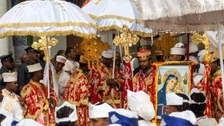

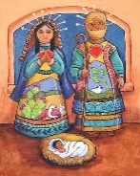
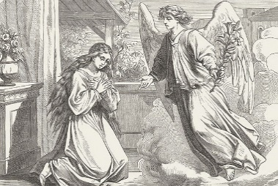
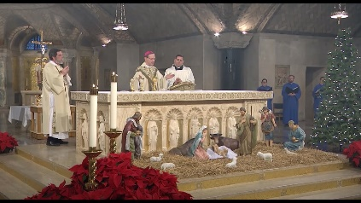

Global theme: Sustainable Development

Key Concepts:
Key events in the Christmas story.
Interpretations
Matthew and Luke’s Gospels
Christmas around the World
2. Explain what interpretation means.
Discuss the word ‘interpretation’ and learn the story of The Elephant and the Blind Man. Reflect on our own interpretations and biases and discuss the role of interpretation in religious and non-religious contexts.
- Explain the meaning of advent and how Christians prepare.
Explain how Advent relates to Christmas, create a Christingle and explain the symbolism involved.

3. Investigate similarities and differences between
Matthew and Luke’s version of the nativity.
Explain how Luke gives value to undervalued people in Biblical time and draw comparisons between Luke and Matthew’s version of events. Compare. to other religions
- Explain how Christians in different countries celebrate Christmas differently.
Explain how Christmas is celebrated by Christians in the UK. Explain that people may celebrate the same festival in different ways and investigate traditions across the world. Complete an activity on the story of Babushka.

RE. Year 6 Spring 1. Christianity - The Christmas Story
- Recall the key events in The Christmas Story.
Recall the Christmas story and identify and discuss the significance for Christians. Reflect on our own religious views and make comparisons. Complete a sequencing activity on The Christmas Story.

4. Explain the key truth within both versions of The
Christmas Story in the Gospels.
Explain how The Christmas Story is interpreted differently by Christians. Evaluate key parts of The Christmas Story to discover the key truth for all Christians. Reflect on literal and metaphorical interpretations of religion and evaluate these ideas in the context of our own religious views.

