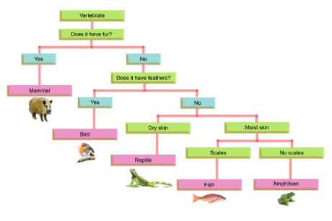
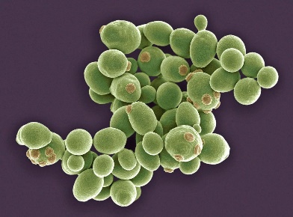
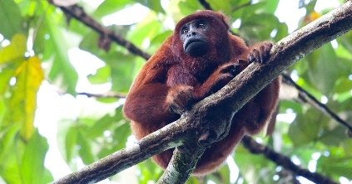
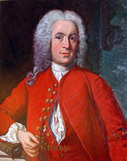
- We will …
>look at the key groups in which animals can be grouped into
>learn the characteristics of those groups
>learn the technical vocabulary for those groups
- We will …
>learn what microorganisms are
> learn about how bacteria can be both helpful and harmful
> conduct an experiment to explore how microorganisms grow
5/6. We will …
>look at the idea of classification
>use our skills as scientist and knowledge of different classifications to organise living things into groups
Vocabulary:
- Vertebrates
- Invertebrates
- Characteristics
- Classify
- Taxonomist
- Key
- Bacteria
- Microorganism
- Microscope
- Species
- Bacteria
- Yeast

How can our understanding of habitats and living things help us protect the planet?
Global theme: Sustainable Development
As Scientists we will:
> use scientific language accurately relating to habitats and living things
> make comparisons between different groups of living things, pointing out their similarities and differences
> draw accurate flow charts to help myself and peers to classify living things
>conduct an experiment to investigate the impact of microorganisms in food

- We will …
>learn about Carl Linnaeus and the classification system
>learn about the impact Carl Linnaeus had on the world
- We will …
>recap our learning from Y4 on vertebrates and invertebrates
>organise living things native to the Amazon into these groups

Living things and their habitats

