
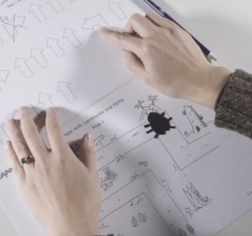


Lesson 4: Learners will design, create, and test a mat for a floor robot. This will introduce the idea that design in programming not only includes code and algorithms, but also artefacts related to the project, such as artwork.

Lesson 3: Learners will use logical reasoning to make predictions. They will follow a program step by step and identify what the outcome will be.

Lesson 2: Learners will focus on sequences, and consider the importance of the order of instructions within a sequence. They will create sequences using the same instructions in different orders. They will then test these sequences to see how the different orders affect the outcome.

Lesson 1: Learners will follow instructions given to them and give instructions to others. They will consider the language used to give instructions, and how that language needs to be clear and precise. Learners will combine several instructions into a sequence that can then be issued to another learner to complete. They will then consider a clear and precise set of instructions in relation to an algorithm, and will think about how computers can only follow clear and unambiguous instructions.

In this unit learners will
- Learners will understand instructions in sequences and the use of logical reasoning to predict outcomes.
- Learners will use given commands in different orders to investigate how the order affects the outcome.
- They will also learn about design in programming.
- They will develop artwork and test it for use in a program.
- They will design algorithms and then test those algorithms as programs and debug them.

Global Theme:
Human Rights
Lesson 5: Learners will design an algorithm to move their robot around the mat that they designed in Lesson 4. As part of the design process, learners will outline what their task is by identifying the starting and finishing points of a route. This outlining will ensure that learners clearly understand what they want their program to achieve.
Lesson 6: Learners will take on a larger programming task. They will break the task into chunks and create algorithms for each chunk. This process is known as ‘decomposition’ and is covered further in key stage 2. Learners will also find and fix errors in their algorithms and programs. They will understand this process to be ‘debugging’.
Computing: Spring 2
Algorithms and debugging

