


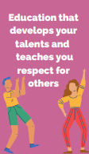

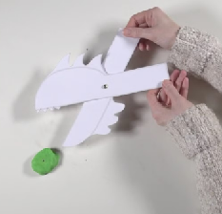
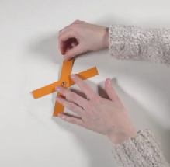
Human Rights

Purpose: To follow a design plan to make a monster with a working mechanism
Key Concepts:
Master practical skills
This concept involves developing the skills needed to make high quality products.
Design, make, evaluate and improve
This concept involves developing the process of design thinking and seeing design as a process.
Take inspiration from design throughout history
This concept involves appreciating the design process that has influenced the products we use in everyday life.

3. We will design a moving monster, based on a design brief. Once finished, we will evaluate our designs against the design criteria.
- 2. We will experiment with different linkages and explore how these work. We will then make two different linkage systems and evaluate these.

1. We will explore different objects, how they move and if they have a mechanical part. We will investigate levers and linkages and then sketch a toy (mechanical, wind-up or puzzle) and evaluate it.

Design and Technology: Spring 2 Moving Monsters
4. We will make our moving monsters using our design from the previous lesson. We will then decorate our monsters. Finally, we will evaluate our monsters to ensure we have fulfilled all the aspects of the design criteria.

