
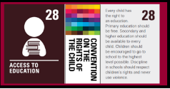

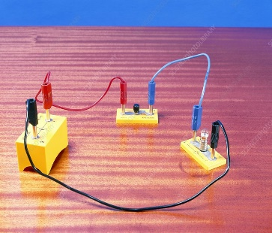
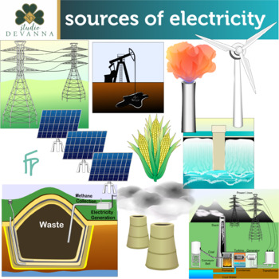
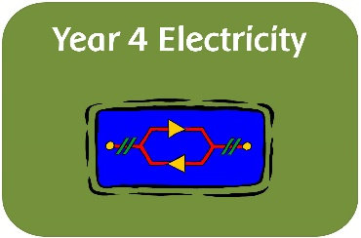
Week 5 –
To recognise that a switch opens and closes a circuit and associate this with whether a lamp will light in a simple circuit.

Skills we will be using:

- Ask relevant questions.
- Gather, record classify and present data in a variety of ways to help in answering questions.
- Identify differences, similarities or changes related to simple, scientific ideas and processes.
- Report on findings from enquiries, including oral and written explanations, displays or presentations of results and conclusions.
- Use results to draw simple conclusions and suggest improvements, new questions and predictions for setting up further tests.
- Identify common appliances that run on electricity.
- Construct a simple series electrical circuit, identifying and naming its basic parts, including cells, wires, bulbs, switches and buzzers.
- Identify whether or not a lamp will light in a simple series circuit, based on whether or not the lamp is part of a complete loop with a battery.
- Recognise that a switch opens and closes a circuit and associate this with whether or not a lamp lights in a simple series circuit.
- Recognise some common conductors and insulators, and associate metals with being good conductors.

Week 6 –
Twinkl Assessment
Week 4 –
Recognise some common conductors and insulators, and associate metals with being good conductors.
Week 3 –
Identify whether a lamp will light in a series circuit, based on whether the lamp is part of a complete loop with a battery.

Week 2 –
Construct a simple series electrical circuit, identifying and naming its basic parts (cells, wires, bulbs, switchers, buzzers).

Week 1 –
Identifying common appliances that run on electricity.

Where do we get electricity from, how does it work and what makes a complete circuit?
Y4 – Spring 2
Electricity

