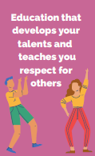



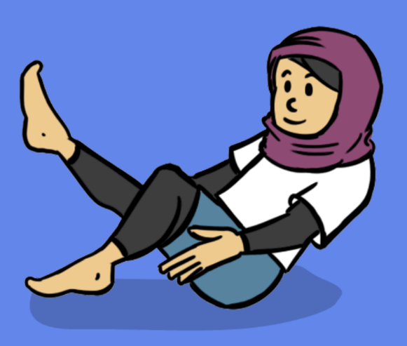
Human Rights
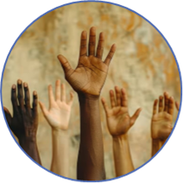
4. We will learn to copy, remember and repeat actions using facial expressions to show different characters. We will work safely around others.
- 3. We will use counts of 8 to help stay in time with the music. We will share ideas with a partner and be respectful giving feedback.

1. We will learning to remember, repeat and link actions to tell the story of our dance. We will watch other’s dances and give feedback and will explore a task independently before asking for help.

PE: Dance Spring 2
- 2. We will develop an understanding of dynamics and how they can show an idea. We will work with a partner to create a dance and develop our confidence to perform.

5. We will be exploring pathways and levels. We will collaborate with a partner, be confident to perform and reflect on our dance so far.
6. We will be remembering and rehearsing our circus dance showing expression and character. We will persevere when rehearsing our dance and make improvements following reflection.
Purpose: To develop our skills in dance to create dances based on the themes of ‘Secret Garden’ and ‘The Circus’
Key Concepts:
Develop practical skills in order to participate, compete and lead a healthy lifestyle
This concept involves learning a range of physical movements and sporting techniques.

