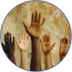
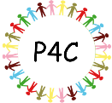
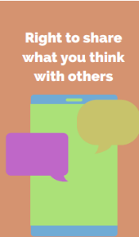

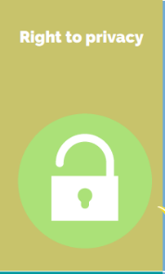
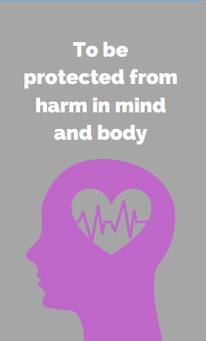
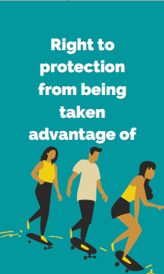
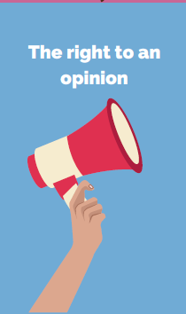
Human Rights
4. Then we will consider the dangers outside of the home. Bikes, railways, water, needles and glass. We will look at the dangers these pose and how to avoid them.
3. Next we will look at how to stay safe. We will learn what to do in an emergency. We will learn about the dangers in the home and how to keep safe.
What should we do to ensure we live in the best place possible?

RHE Spring 2: Safety
- We will look real and fake news stories. We shall think about why someone might put fake news stories onto the internet. We shall create some true and some fake news stories for other classes to work out which are real and which are fake
2. Then we will read and discuss the story Proud. We will think about things which are good at and what we are not so good at.
Purpose: To understand how to keep ourselves safe.
Key Concepts RHE
- Recognise rules and age limits are put in place to keep us safe online.
- Recognise how to keep safe familiar and unfamiliar environments.
- Identify how to ask for help if they feel unsafe or worried and what vocabulary to use.
- Know to ring 999 in an emergency.
5. Next we will explore road safety. We will learn about the dangers and how to cross the road safely.
6. We will look at sun safety. We will learn how to keep safe in the sun and the consequences of not covering up and taking precautions.

