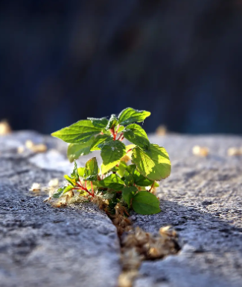

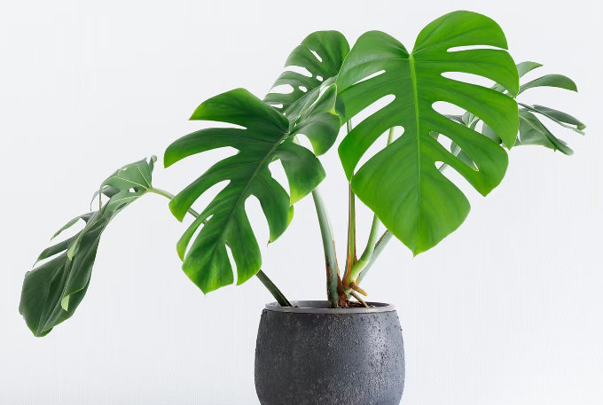
Unit outcomes

Pupils who are secure will be able to:
- Recall that seeds have all the necessary parts inside for plants to grow.
- Recall that seeds need water and warmth to germinate.
- Recognise that light is required for healthy plant growth.
- Sequence the stages of a plant’s life cycle.
- Recognise the importance of healthy plant growth.
- Describe the influences humans have on plants in the environment.
When working scientifically, pupils who are secure will be able to:
- Set up comparative tests.
- Plan observations and measurements.
- Use rulers to measure and record stem height.
- Record plant growth data in a table.
- Compare plant growth in different test conditions.
- Use a magnifying glass to observe and compare plants.
- Draw diagrams to represent stages of a plant’s life cycle.

Lesson 5 & 6: What do plants need to stay healthy? We will learn to recognise what plants need for healthy growth. We will explore science in action by recognising that humans have a responsibility to care for plants.

Science: Spring 2
Plants
Human Rights

Lesson 4: Light and plant growth
We will learn to describe the effect of light and on plant growth. We will work scientifically by observing and using a magnifying glass.

Lesson 3: Lifecycle of a plant.
We will learn to identify stages of a plant’s lifecycle. We will work scientifically by drawing and labelling diagrams.
Lesson 2: What’s inside a seed?
We will learn that seeds and bulbs contain what they need to grow into a plant. We will work scientifically by measuring with a ruler.

Lesson 1: What do plants need to grow?
We will learn that seeds need certain conditions for growth. We will work scientifically by planning a comparative test.

