
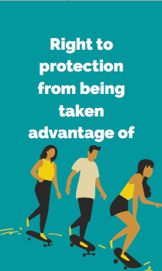


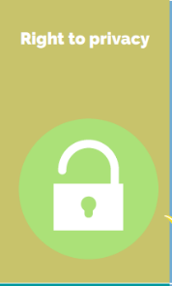
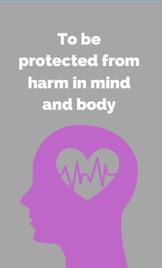
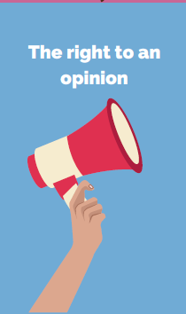
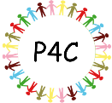
Power and Governance
Key Concepts RHE
- Identify the difference between happy surprises and secrets that make them feel uncomfortable or worried, and how to get help
- Recognise how to resist pressure to do something that feels uncomfortable or unsafe
- Identify how to ask for help if they feel unsafe or worried and what vocabulary to use
Purpose: To understand people need to ask for consent to touch your body.
6. We will look at what are the best and worse bits of each age stage. We will then go on to look at how people defy age expectations.
5. Next we will explore Will I always be a child? We will look at the 5 stages of life. We will order them and discuss different questions at each stage.
4. Then we will look at the difference between a secret and a surprise. We will act out different scenarios. Then we will create posters to teach younger children the Pants rules.
- We will look at the question when should I say no? We will read and discuss the story No Means No. Then we will watch a video clip about giving consent.
How do people make the best out of events in their lives?
Consent
3. Then we will ask the question Who owns my body? (I do). We will recap the Pants rules. We will read and discuss Miles is the Boss of His Own Body.
2. Next we will look at whether some parts of our bodies are more private than others. We will role play asking for consent.

