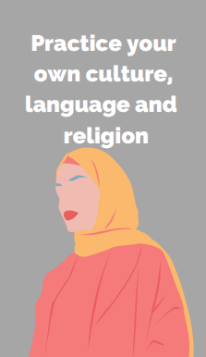
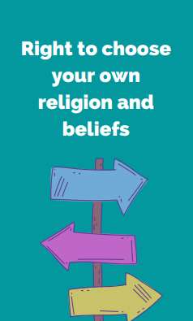



6. Finally we will look where some prayers come from. We will discuss how some people use prayer books and scripture when they pray and why some people choose to use the same prayers. We will also look at what prayer means to different people.
4. We will now look at why some people use special objects and clothing during prayer. We will discuss the importance of special prayer objects and clothing and look at how some Jewish and Muslim people might pray.
Y2
Summer 1
3. Next we will look at how different people use their bodies to pray. We will look at how people prepare for prayer.
2. We will look further into how some people pray and what this can look like. We will compare how different people pray.
- First we will look at why some people might choose to talk to God. We will look at prayers and how people might communicate with God.
Power and Governance
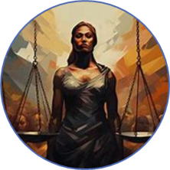
5. Next we will look at how Hindu people pray. We will identify key elements of Hindu prayer spaces and rituals and explain the significance of murti and other objects in Hindu prayer.
Key Concepts RE:
- Describe what prayer means
- Identify some reasons why people might pray.
- Explain how some people use their bodies during prayer.
- Identify some similarities and differences between the ways in which people pray.
- Understand why special objects and items of clothing are important to some people when they pray.
- Draw connections between prayer practices within the Hindu, Muslim and Jewish worldviews.
How do some people talk to God?

