
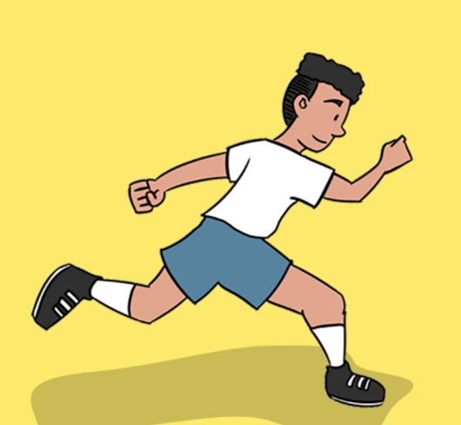
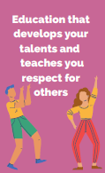


Power and Governance
PE: Athletics Summer 1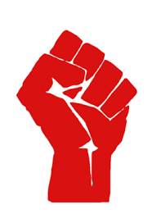
6. We will be selecting and applying knowledge and technique in an athletics carousel, working independently and supporting a partner to achieve our best.
5. We will be developing our throwing for accuracy, keeping our eyes looking at the target, pointing our hands at the target after we throw and throwing from a balanced starting position.
4. We will be developing throwing for distance, placing our opposite leg to throwing arm forward, standing sideways on to the direction of the throw and throwing from a balanced starting position.
- 3. We will be developing our technique for jumping for height, jumping from a balanced starting position, looking forward at at take off and landing and using our arms to jump higher.

1. We will be developing a sprinting action, learning to balance when running by alternating arms and legs, run on the balls of our feet and take big strides when running fast. We will learn to understand and recognise good technique.

- 2. We will be developing jumping for distance, bending our knees to take off and land and how to use our arms for taking off and landing. We will also be striving to improve our technique.

Purpose: To develop our skills required for athletic activities such as running at different speeds, jumping and throwing.
Develop practical skills in order to participate, compete and lead a healthy lifestyle
This concept involves learning a range of physical movements and sporting techniques.

