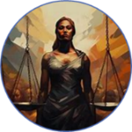

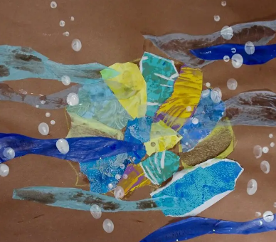
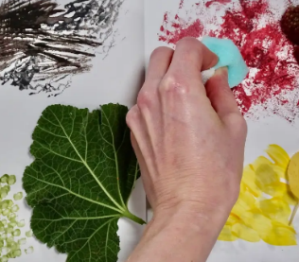



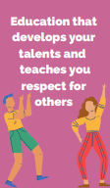
B v
Power and Governance
Art and Design: Summer 1 Painting and Mixed Media: Life in Colour
Purpose: To use our knowledge of colour mixing, texture and pattern to create a collage
Key Concepts:
Develop ideas
This concept involves understanding how ideas develop through an artistic process.
Master techniques
This concept involves developing a skill set so that ideas may be communicated.
Take inspiration from the greats
This concept involves learning from both the artistic process and techniques of great artists and artisans throughout history.

5. We will evaluate our artwork, explaining what we like or don’t like and how we could make improvements.
4. We will be composing a collage, choosing and arranging materials for effect, trying out different arrangements for effect, including overlapping and describing how our choices match our ideas.
3. We will use paint to explore texture and pattern, choosing materials and tools to create texture and mixing colours to match something we see.
- 2. We will be learning to create texture with paint, describing colours and textures, choosing tools to paint with and mixing a range of secondary colours.

1. We will develop our knowledge of colour mixing, naming primary and secondary colours, describing what happens when we mix two secondary colours and making choices about how to make colours lighter and darker.

