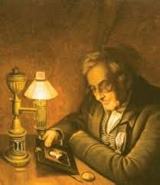
Light
1 We will start to explore light and its influence during the Victorian era. What power it has and how light travels.

2 Secondly, we will look at how the human eye works and how it sees light. We will then move onto how light reflects

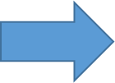

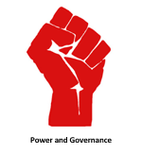

What power does light give us?

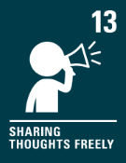
Purpose: To Understand light and seeing

Key concepts:
- Understand that light appears to travel in straight lines
- Use the idea that light travels in straight lines to explain that objects are seen because they give out or reflect light into the eyes
- Use the idea that light travels in straight lines to explain why shadows have the same shape as the objects that cast them, and to predict the size of shadows when the position of the light source changes
- Explain that we see things because light travels from light sources to objects and then to our eyes.
3 Next we will look at refraction and why it happens. We will observe images using water and record what happens.

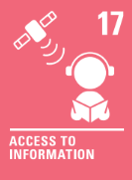
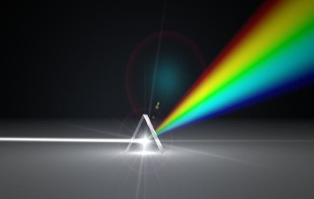
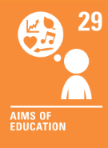
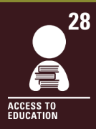
- prism
- spectrum
- absorption
- dispersion

Vocabulary we will be using:
- opaque
- transparent
- translucent
- reflect
- refract
5 Finally, we will explore why we see colour.

4 After, we will look at how light is reflects and try to create our own rainbow. We will describe what we see.

