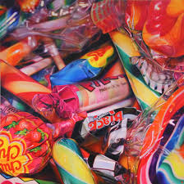
1. Photomontage
To apply an understanding of composition to create an effective photomontage advertising poster.

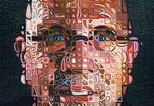
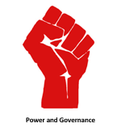
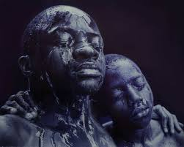
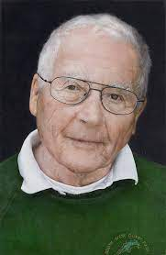
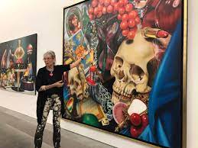
What does it mean to be powerful?
Focus: Power and Governance
Key concepts: How ideas develop through an artistic process.
Purpose: Create a final painting or drawing with tonal differences that create a photo-realistic effect.

3. Digital Art
To demonstrate an understanding of design choices using digital photography.
4. Photorealistic Self-Portraits
To demonstrate observation and proportion to create art in a photorealistic style.
2. Macro Photography
To apply an understanding of abstract art through photography.

