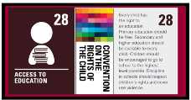

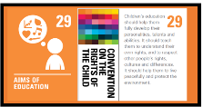

Week 3
We will be looking at how heat can change solids to liquids and identifying materials that melt at different temperatures.
We will use a material to test its freezing and melting temperatures.
Week 2
We will be looking more closely at gases and their properties and conducting a test thinking about the weight of a gas.
Week 6
We will study the water cycle and design an experiment to demonstrate different parts of the water cycle/assessment
Investigate materials
This concept involves becoming familiar with the properties of a range of materials, how they are used and how they can be changed.
Work scientifically
This concept involves learning the methodologies of the discipline of science.
Skills we will be using:

- Ask relevant questions.
- Gather, record classify and present data in a variety of ways to help in answering questions.
- Identify differences, similarities or changes related to simple, scientific ideas and processes.
- Report on findings from enquiries, including oral and written explanations, displays or presentations of results and conclusions.
- Use results to draw simple conclusions and suggest improvements, new questions and predictions for setting up further tests.
- Compare and group materials together, according to whether they are solids, liquids or gases.
- Observe that some materials change state when they are heated or cooled, and measure the temperature at which this happens in degrees Celsius (°C), building on their teaching in mathematics.
- Identify the part played by evaporation and condensation in the water cycle and associate the rate of evaporation with temperature.

What are different states of matter and how do they change from one state to another?
What is the water cycle and how does it work?

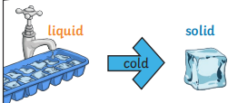
Week 5
We will look at the process of evaporation and plan a comparative test to using scientific equipment accurately.

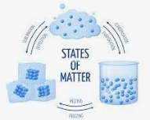
Week 4
We will focus on the different states of water and the temperatures that cause it change state.
We will look at the processes that cause water to change state.

Y4
States of Matter
Week 1
We will be identifying solids, liquids and gases and describing their properties as well as looking at why they are different because of the difference in their particles.

